Belousov-Zhabotinsky oscillatory reaction and chemical waves

Safety:
Wear gloves and safety glasses during the entire time in the lab. Dispose off all used reagents and reactions mixtures into waste containers.

PROCEDURE

Part I: BZ oscillations in batch reactor
In Step 1 you will set up Vernier Spectrometer for data collections. In Step 2 you will prepare BZ mixture and in Step 3 you will follow the oscillations in a batch reactor.

Step 1. Use your Brandeis username to log in into a PC. Make sure that a Vernier spectrometer is connected to a USB port of your PC. Start the Logger Pro program from Desktop. To calibrate the Spectrometer, choose Calibrate → Spectrometer from the Experiment menu. The calibration dialog box will display the message: “Waiting …seconds for lamp to warm up.” Prepare a blank sample: a cuvette filled 3/4 full with distilled water. The sample in the cuvette must be free of bubbles and the cuvette should be wiped clean and dry on the outside with a Kimwipe. Place the cuvette into the spectrometer. Make sure that the light passes through the clear sides of the cuvette. Follow the instructions in the dialog box to complete the calibration. Then click OK . NOTE: If the spectrometer is not active after starting the Logger Pro program go to Experiment menu → Connect Interface → Spectrometer → Scan for Spectrometers.
Step 2. Insert a stir bar into a clean, dry 30 mL beaker and place the beaker on a stirrer. Using an automatic pipettor and labeled tips add the prescribed amount of the BZ reagents into the beaker. Add the reagents in the order as they are listed in the table. Start stirring the solution after addition of the first reagent. After the addition of NaBr solution wait about 20 seconds until the solution turns colorless. Only then add the last reagent - ferroin into the reaction mixture. The solution must turn yellow after the addition of NaBr solution. If it does not, empty the beaker into a waste container and start over.
Volumes to be added to the beaker:

Step 3. Using an automatic pipettor transfer 2.00 mL of the BZ solution from the beaker into a cuvette with a small stir bar. Place the cuvette with the solution in the Spectrometer. Make sure that the light passes through the clear sides of the cuvette. Click on the Configure spectrometer icon, , located on the right hand side of the toolbar. Select Abs vs. Time (under Set Collection Mode). The wavelength of the maximum absorbance at 520 nm should be automatically selected, if not select this wavelength manually. Click OK to close the display and then click Collect. Follow the oscillations for about 20 minutes and then click STOP to end the data collection. Evaluate the period of oscillations from the plot. During the time you record the oscillations continue with Part II.

Part II: BZ waves on a Petri dish
Add 0.80 mL of ferroin to the solution in the beaker that you prepared in Part I, Step 2. Pour the mixture from the beaker onto a Petri dish and gently shake the solution so the bottom of the Petri dish is completely covered. Place the Petri dish with the BZ mixture on a light table, put a cover on top of the dish and turn on the light. Observe the waves as they form. Use a silver wire to touch the mixture on the Petri dish and observe if a target pattern is formed. After about 20 minutes estimate the wavelength of a selected pattern. At the end shake the Petri dish to remove bubbles of CO₂ and observe it the pattern reappears.
Dependence on reagent concentration
Study the role of concentration of H₂SO₄ and/or malonic acid (MA) on the oscillatory behavior of the BZ reaction. Select one of the mixtures from the Table below and repeat Part I (Step 2 and Step 3) and Part II with a different composition.
- Dependence on [H₂SO₄]
a) low concentration of H₂SO₄ b) high concentration of H₂SO₄
- Dependence on [MA]
a) low concentration of MA b) high concentration of MA
Using an automatic pipettor
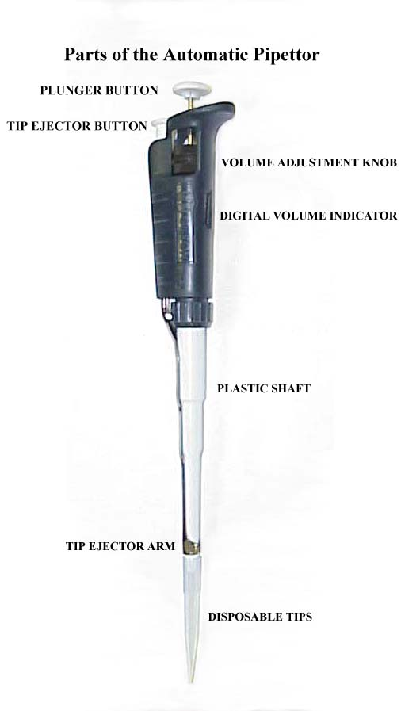
1. Choose the pipettor with a capacity close to, but not more than the desired volume.
2. To set a volume, hold the pipettor in one hand and turn the volume adjustment knob with the other hand until the correct volume shows on the indicator. Some automatic pipettors have a friction ring on the knob which "locks" the volume.
3. Attach a disposable tip by pressing firmly a plastic tip of proper size to the shaft of the pipettor to ensure a positive airtight seal.
4. Depress the plunger button gently to the first (“soft”) stop. It is this first stop that extends the piston to the calibrated volume displayed on the digital indicator.
5. Immerse the tip of pipet into the sample liquid to a depth of few millimeters below the liquid surface and draw up the sample. Allow the pushbutton to return slowly to the fully extended position and draw the sample into the pipet tip. Keep the bottom of the tip below the liquid surface during the sample suction. Wait a few seconds to ensure that the full volume of sample is drawn into the plastic tip.
6. Remove the tip from the sample liquid and dispense the sample from the pipettor into the receiving vessel. Depress the plunger button slowly to the first stop and wait until the liquid stops flowing. Then press down the plunger button to the second (“full”) stop and expel any liquid from the tip.
7. With the plunger fully depressed, withdraw the pipet from the receiving vessel. Allow the plunger to return to the fully extended position. Discard the tip by depressing the tip ejector button.

