Vivekanand Pandey Vimal
The Chaotic Dynamics of the Pendulum and the Lorenz Circuit
Friday, December 15, 2006
A. Introduction and Theory:
For a long time in the history of physics, many assumptions and simplifications were made to tame the real world. Even now, in introductory physics classes, topics like air drag, Brownian motion and other factors that lead to unpredictable behavior are ignored or over simplified. Recently, however, with the growing computational power of computers, physicists have been able to study the various aspects of chaos.
A system becomes chaotic when it no longer repeats its past behavior and as a result one can no longer predict its behavior. The best way to test for chaotic behavior is to examine its sensitivity to initial conditions. For nonchoatic systems, if two separate but very close initial conditions are picked, the system’s uncertainly will evolve in a linear manner. In contrast, for a chaotic system, the same treatment will lead to the exponential evolution of error. For this reason, even after a little while, predictions of the system become very inaccurate and unreliable. While it may seem that chaotic systems are completely random, close analysis proves that chaotic systems are governed by equations, many of which are derived from Newton’s Laws of Motion.
Chaotic systems only need two conditions:
1) there must be atleast three dynamic variables that are independent of each other.
2) the equations of motion must be coupled and nonlinear
An example of these requirements is the following, so long as n≥3:
dx₁/dt = F₁(x₁,x₂,...,x_{n})
dx₂/dt = F₂(x₁,x₂,...,x_{n})
.
.
.
dx_{n}/dt = F_{n}(x₁,x₂,...,x_{n})

An example of a function could be the equation below, in which x1 and x2 are related in a nonlinear manner:
F₁(x₁,x₂,...,x_{n}) = αx₁+ βx₂+ γx₁sinx₂+ δx_{n}
To understand and investigate chaotic behavior, we performed two experiments. In the first equation we examined the behavior of a driven pendulum and in the second experiment we experiment with a Lorenz circuit.
- Part One: The Driven Pendulum
To model our pendulum we use the rotational version of Newton’s Second Law, this is given by:
$Iα=\sum{τ}$
If we write this equation in differential form and expand using the following pieces of information: I = mL² and τ = L x F = -mgsinθ, we obtain (refer to free body diagram in appendix for clarification), where L is the length of the pendulum:
${\text{mL}}^{2}\frac{d^{2}θ}{{\text{dt}}^{2}}=−\text{mgL}\text{sin}θ$
To account for air drag we include a linear damping force proportional to the velocity. Also, we add a sinusoidal driving term to accurately model the driven pendulum. Our new equation becomes:
${\text{mL}}^{2}\frac{d^{2}θ}{{\text{dt}}^{2}}=−\text{mgL}\text{sin}θ−b\frac{dθ}{\text{dt}}+A\text{cos}(w_{D}t)$,
where w_{D} represents the angular velocity of the forcing and A is the amplitude. By making this equation dimensionless we can reduce the number of parameters, therefore making it simpler for computation and analysis. This is accomplished by changing the unit of time to, t = t’(L/g)^{1/2}. Plugging this into our equation, we obtain:
$$\left(\frac{g}{L}\right){\text{mL}}^{2}\frac{d^{2}θ}{{\text{dt}}^{2}}=−\text{mgL}\text{sin}θ−\left(\sqrt{\frac{g}{L}}\right)b\frac{dθ}{\text{dt}}+A\text{cos}(w_{D}t)$$
Simplifying and reordering the equation, we obtain the final product:
$$\frac{d^{2}θ}{{\text{dt}}^{2}}+\frac{1}{q}\frac{dθ}{\text{dt}}+\text{sin}θ=g\text{cos}(φ)$$
where q is the damping parameter and g is the forcing amplitude (not the acceleration due to gravity) and φ=w_{D}*t. We can express this differential equation as three first order coupled differential equations, much in the form of the equations presented in the theory section:
$$\begin{aligned}\frac{dω}{\text{dt}}=−\frac{1}{q}ω−\text{sin}θ+g\text{cos}(φ) \\ \frac{dθ}{\text{dt}}=ω \\ \frac{dφ}{\text{dt}}=ω_{D}\end{aligned}$$
Analysis of these equations proves that the prerequisites for chaotic behavior are met:
- There are three independent variables: ω,θ,φ
- The equations are coupled and have nonlinear terms as can be seen in the sinusoidal terms in the first equation.
For the proper values of the parameters, g, w_{D} and q, one can see chaotic motion. Before continuing it would be fitting to discuss the different tools we used to analyze the data. This discussion is also relevant to our second experiment.
The most basic representation of the data is the phase diagram, in which the angle (θ) appears on the x-axis and the angular velocity (ω) appears on the y-axis. It is also possible to create a three dimensional phase diagram in which the z-axis is the phase (φ). When making these graphs, it is always useful to discard the first hundred measurements so that the transient behavior does not appear on the diagram.
A repeated closed loop signifies a periodic state. Two closed loops mean that the pendulum has entered into a period doubling state. Whereas, a chaotic state is represented by erratic lines that do not repeat or show any periodicity. Greater discussion and analysis with actual diagrams will be given in the results section.
Because the phase diagram records every point, it can become rather messy and difficult to read. The solution to this problem is a Poincare plot, which samples the phase diagram at a fixed time interval, typically equal to the period of oscillation (although in chaotic motion there is no discernable period). This stroboscopic method allows one to extract several data points from thousands. In a Poincare plot, single-loop periodic motion is represented by a single dot because this means that the phase diagram repeats and is the same at each time interval. For similar reasons, a period doubling phase diagram is represented by two dots in a Poincare plot, because for every time increment there are only two possible locations it can be. Finally, for a chaotic system, there will be many dots and they will be spread out.
The last graphical tool is a bifurcation diagram. In bifurcation diagrams the values for the Poincare plots are plotted against different values for a parameter. For example, one can collect Poincare plots from many different g-values. By picking one variable (from either ω,θ,φ), one can plot the Poincare plot for that variable on the y-axis and the corresponding g-value on the x-axis. This allows one to see the progression of the system from periodic to chaotic.
In most bifurcation diagrams, the graph begins with a single line, representing a single point in each Poincare plot (signifying periodicity), then a characteristic bifurcation occurs when period doubling is noticed and the line splits into two different lines (now there are 2 dots in each Poincare plot). Sometimes the system undergoes period quadrupling. Eventually, when one enters into the chaotic regime, there are many dots.
- Part Two: The Lorenz Circuit
In this section we experimented with an analog circuit that allowed us to
electronically integrate the Lorenz equations. By using a Multiplying Digital Analog Converter, we were able to adjust the value of a resistor in the circuit, allowing us to bring the system from periodicity to chaos. As described above, to reach a state of chaos we need three independent variables that are placed in nonlinear coupled differential equations, they are:
$$\begin{aligned}\frac{\text{dx}}{\text{dt}}=s(y−x) \\ \frac{\text{dy}}{\text{dt}}=\text{rx}−y−\text{xz} \\ \frac{\text{dz}}{\text{dt}}=\text{xy}−\text{bz}\end{aligned}$$
in which, s = 10, b=8/3, and r can be changed. With the help of analogue digital converters and Labview, we were able to record these three voltages that were outputted by the circuit, representing the solutions of the Lorenz equations: x(t), y(t) and z(t).
To analyze the data, we used all the tools mentioned above, but we initially encountered problems when trying to construct the Poincare plots. This is because when creating a Poincare plot, one must pick the points at the appropriate time interval. For example, imagine a periodic function in which the point is extracted at intervals significantly smaller than the period. In this case, the Poincare plot would show many points even though the function is completely periodic. It is, therefore, very important to choose a time interval that is very close to the period of the actual data.
To find the period of the data, we decided to use the Fourier Transform to construct a Power Spectrum of the function. To begin with, almost any function can be written as the superposition of many sinusoidal terms. If the function is periodic, one only needs to superimpose terms that are integer multiples of the frequency of the function. If, however, the data is very complicated and the frequency is not easily discernable (either because of noise or simply because of its nature) one must use an entire continuum of frequencies to reconstruct the data. The Fourier Series is best suited for periodic functions whereas the Fourier Transform is used for non-periodic or semi-periodic functions.
In the Lorenz circuit, the system can transition from periodic to chaotic. Moreover, we do not know the nature of the data beforehand, as a result the Fourier Transform method is the best approach. We can write the function as:
$$f(t)=\int{a(ω)e^{iωt}}dω$$
where a(w) is frequency dependent amplitude of the function, also known as the Fourier Transform of the function:
$a(ω)=\frac{1}{2π}\int{f(t)e^{−iωt}}\text{dt}$
Because the Fourier transform can output complex numbers, it is useful to look at the power spectrum of a function, which essentially is the real part of the Fourier Transform:
Power Spectrum = |a(w)|²
If a semi-periodic function is written in the format presented above, those sinusoidal terms that are most similar to the frequency of the data will have very large amplitudes, whereas those terms that have very different frequencies will have very small amplitude. As a result, if one plots the power spectrum, there should be spikes at the frequencies that match those of the data. A few examples are provided below and the code we wrote to implement it is in the appendix.
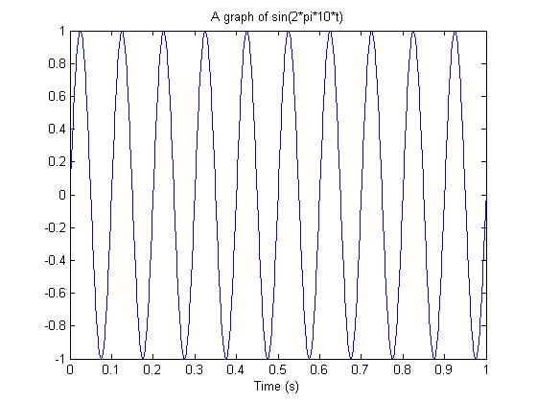
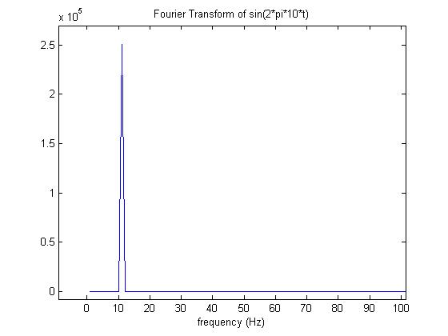
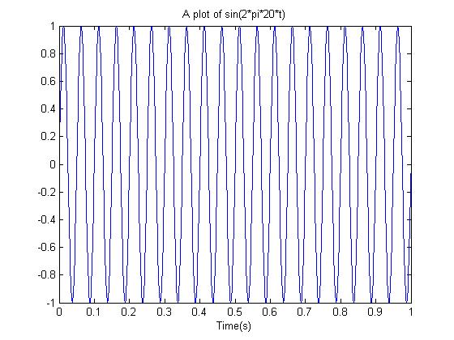
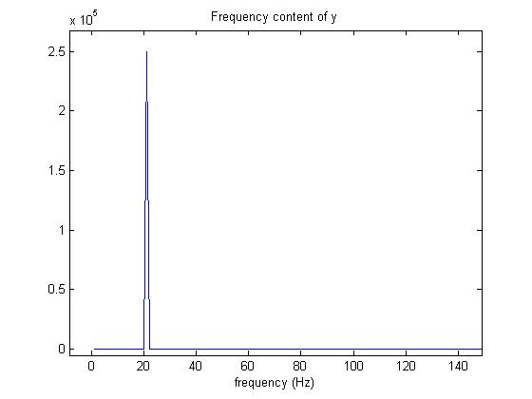
And finally, one in which the function is the addition of the two presented before: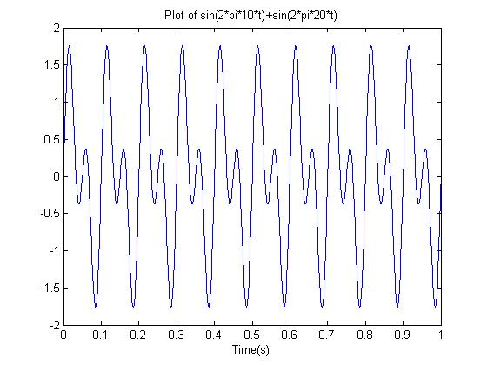
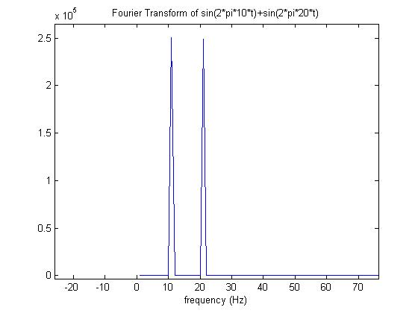

  - Procedure and Results
- Part One: The Driven Pendulum
Before we began the experiments, it was imperative that we obtain information on the pendulum. With this, we would be able to numerically solve the differential equations and compare it to our actual experimental data. Luckily, this information was provided in the packet: w_{o}=9.82rad/sec and b/I=2. The ratio of b/I was controlled by a micrometer on the pendulum (refer to diagram in appendix), we chose a b/I value near 2 because it matched the one used in the textbook.
In the first experiment we performed, we increased the value of the drive frequency and were able to collect data as we went from periodicity to chaos. This method of altering the frequency instead of the forcing amplitude (g) was much different than in the textbook which preferred to alter g. We did this, because the dial that controlled the amplitude had no numbers on it and even when it was increased at even increments, one did not see a corresponding even increase in amplitude. Nevertheless, we devised a way to increase g in experiment two, which will be discussed later.
Below are a series of images, the experimental Poincare plots are juxtaposed next to the theoretical plots of the phase plane and the Poincare plot. The Mathematica code that allowed us to achieve the images is located in the appendix, as well as the website which helped produce some of the images (they used the same implementation, except their graphs were more appealing).
The first three plots below describe periodic motion. This occurs when the natural frequency of the pendulum and the driving frequency of the motor compliment each other, to produce regular predictable motion. The closed loop in the phase plane can be clearly seen and so can its single dot representation in the Poincare plots. Notice that there is great similarity between the experimental and theoretical plots even though the proper g value for the experiment was not acquirable.
The next three diagrams show semi-periodic motion. In the experimental Poincare plot, one can defiantly see two large clouds of points arranged around two different points. This sort of configuration represents period doubling behavior, which can be clearly seen in the theoretical Poincare and phase plots. Period doubling behavior typically occurs when a system is ready to transition from periodicity to chaos.

Theoretical Phase Plot (periodic) with w_{D} = 2/3, g = 0.9, and q = 2
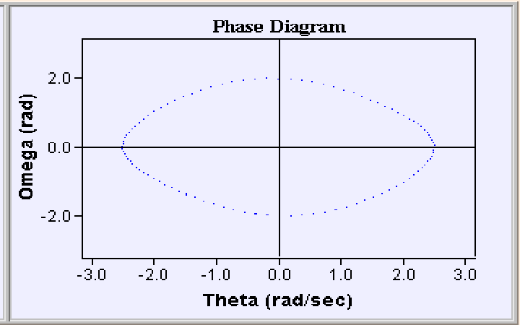

Theoretical Poincare Plot (periodic) with w_{D} = 2/3, g = 0.9, and q = 2
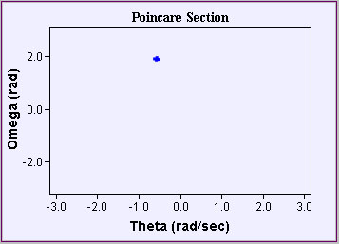
Experimental Poincare Plot of a periodic behavior with q=2
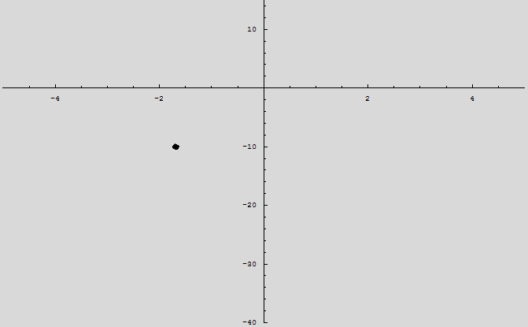

Theoretical Phase Plot (period doubling) with w_{D} = 2/3, g = 1.45, and q = 2
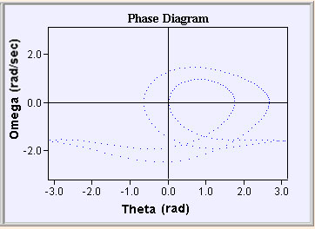

Theoretical Poincare Plot (period doubling) with w_{D} = 2/3, g = 1.45, and q = 2
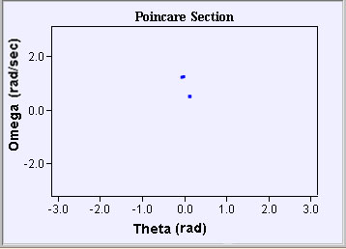
Experimental Poincare Plot of rough period doubling behavior with q = 2
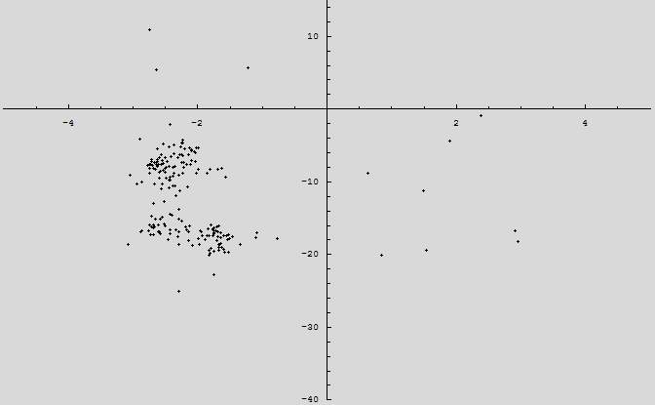
Theoretical Phase plot (chaotic) with w_{D} = 2/3, g = 1.15, and q = 2
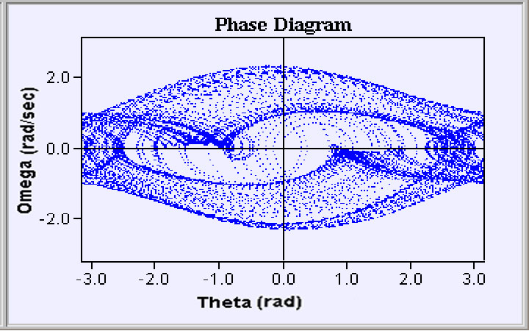

Theoretical Poincare Plot (chaotic) with w_{D} = 2/3, g = 1.15, and q = 2
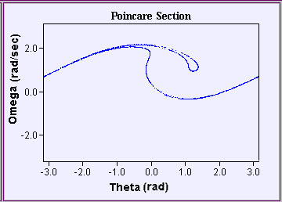

Experimental Poincare Plot of chaotic behavior with q = 2
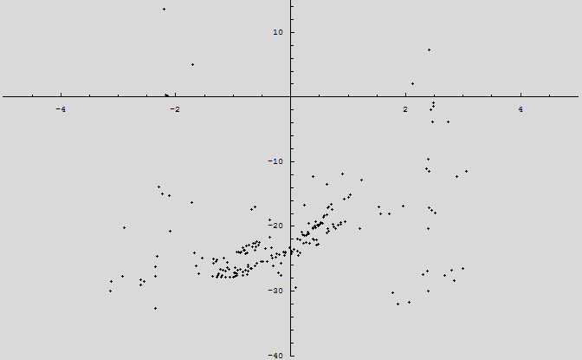
The last three plots above, represent the behavior in the chaotic domain, in which the past history is never repeated. In this situation the experimental data only resembles the numerical data. This is because the experimental data is subject to more outside interference and also because we altered the frequencies instead of the amplitude. Nevertheless, the general figure of the numerical method can be seen in the experimental one, in which the upper curve is represented by a mass of dots. Moreover, the general trend of chaotic motion is found in both Poincare Plots: the dots are not focused at one point but rather spread throughout the diagram, showing that at equal time increments the motion is not the same.
Having finished the experiments in which we altered w_{D,} we created evenly spaced notches on the dial that controlled the g-value, allowing us to use the same incremental increase in g. Next we collected the Poincare plots and created a rough bifurcation diagram that illustrates some of the important features.
Experimental Bifurcation Diagram:
Theoretical Bifurcation Diagram created from Mathematica (code in appendix):
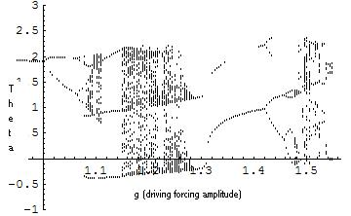
Because we could not obtain exact measurements for the g-value, the x-axis scales differ in both diagrams. Moreover, because it was difficult to make the increments any smaller, our experimental graph is not as detailed as the mathematical one. Nevertheless, there are several similarities. Notice that in both graphs, one begins with periodicity when the driving force is extremely small. On the theoretical bifurcation diagram, this is seen in the negative x region due to programming errors (our Mathematica skills were limited) and in the experimental diagram it is seen as a solitary dot for the first two g-values.
Some hint of period doubling can be seen in the experimental graph because the data point suddenly descends downward and had our apparatus been more accurate, a second point would have been seen. Moreover, evidence of very rough period doubling behavior was displayed in the Poincare plots presented above.
Next, both graphs enter into chaos and there is an abundance of points. The lack of accuracy coupled with the inability to raise the g-value too high (i.e. the dial would not go any farther), prevented us from entering into periodicity, once again, from chaos.
II. Part Two: Lorenz Circuit
We began by setting r=1 and recording the data for x,y, and z. Next we increased r by a value of one and repeated the steps until the system transitioned from periodicity to chaos. At this point we incremented r by four and continued recording data. From the data we were able to easily construct phase plots but had to write extra programs in Matlab to find the Poincare plots.
As discussed in the theory section, in order to create a proper Poincare plot, the period had to be properly determined. To determine the period, we inputted the data into Matlab and created the power spectrum, from which we were able to determine the period of our data. We chose to find the period from r = 1 because we were certain that it lay in the periodic regime, as can be seen by the plot below:
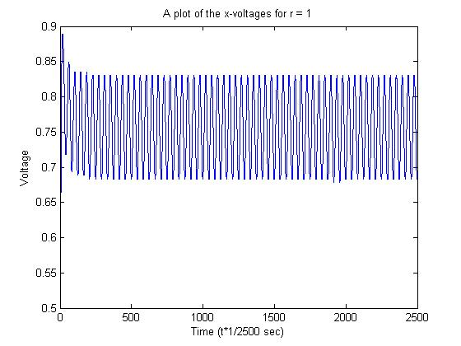
Using our program (provided in the appendix), we plotted the power spectrum:
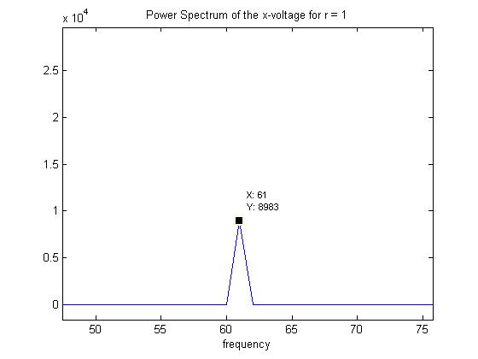
Here it can be seen that the answer is 61, which means that our data oscillates 61 times in the 2500 data points that we have. Therefore, to find the period (i.e. how many data points per one oscillation), we do 2500/61 = 41 points per oscillation.
We wrote another program to go through the data and pick out every 41 points, the value of the voltage and then plot that array as the Poincare plot (this program is in the appendix). Because we acquired so much data, below are only a few selected phase planes and Poincare plots that represent the behavior of the system as we increased the resistance. Periodic:
r=1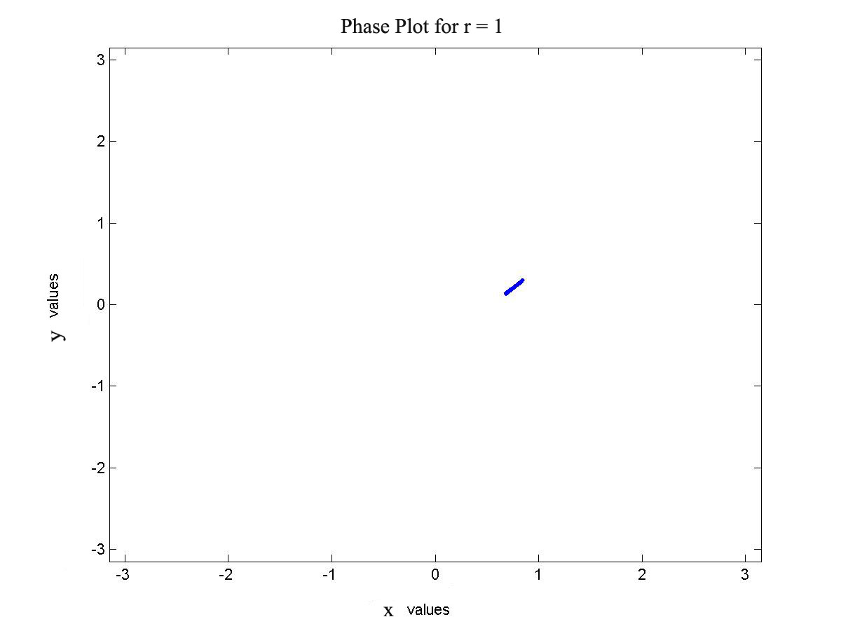
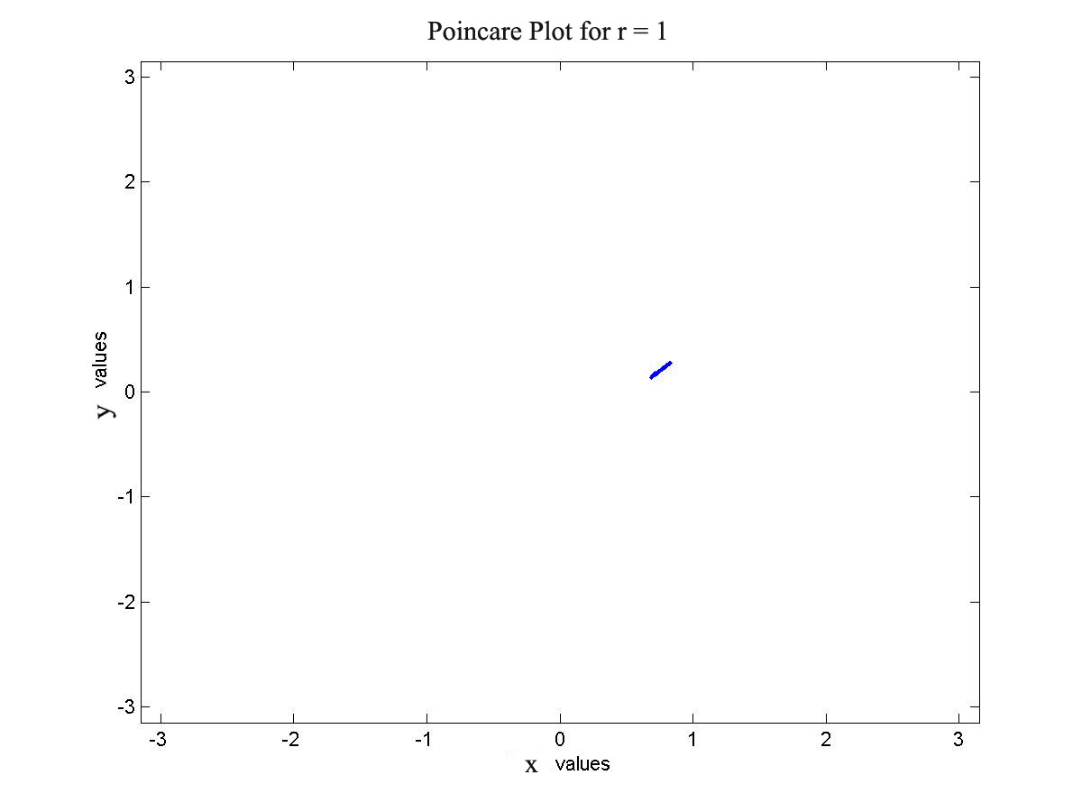

r = 50
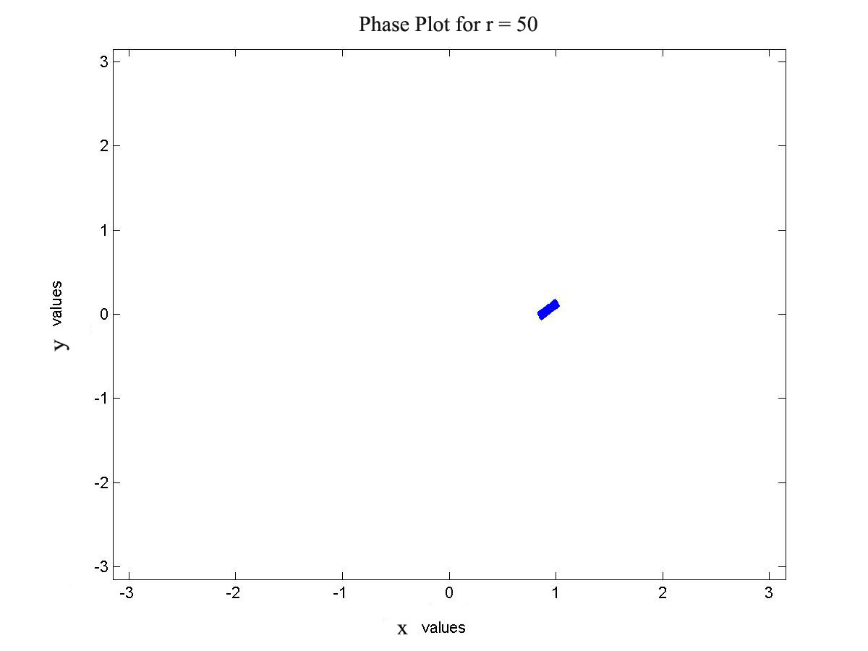
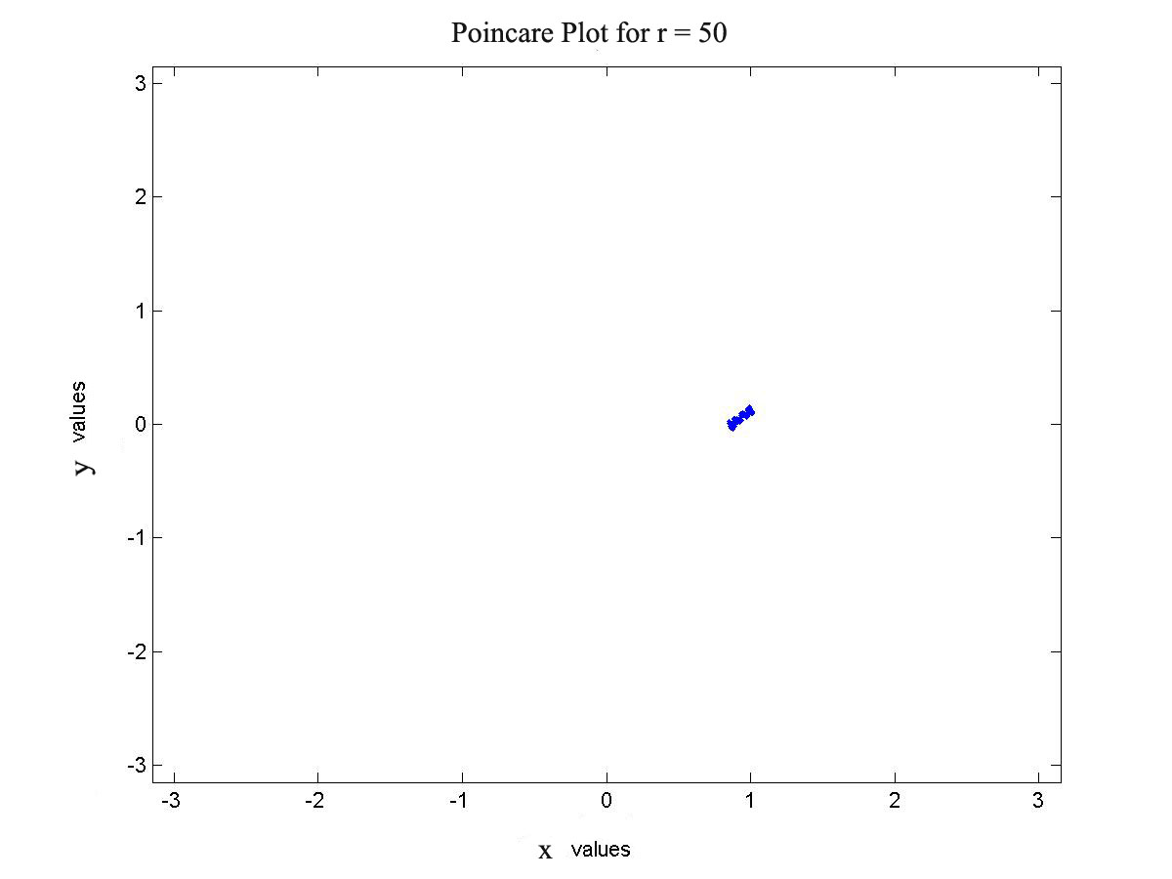
Chaotic:
r=51
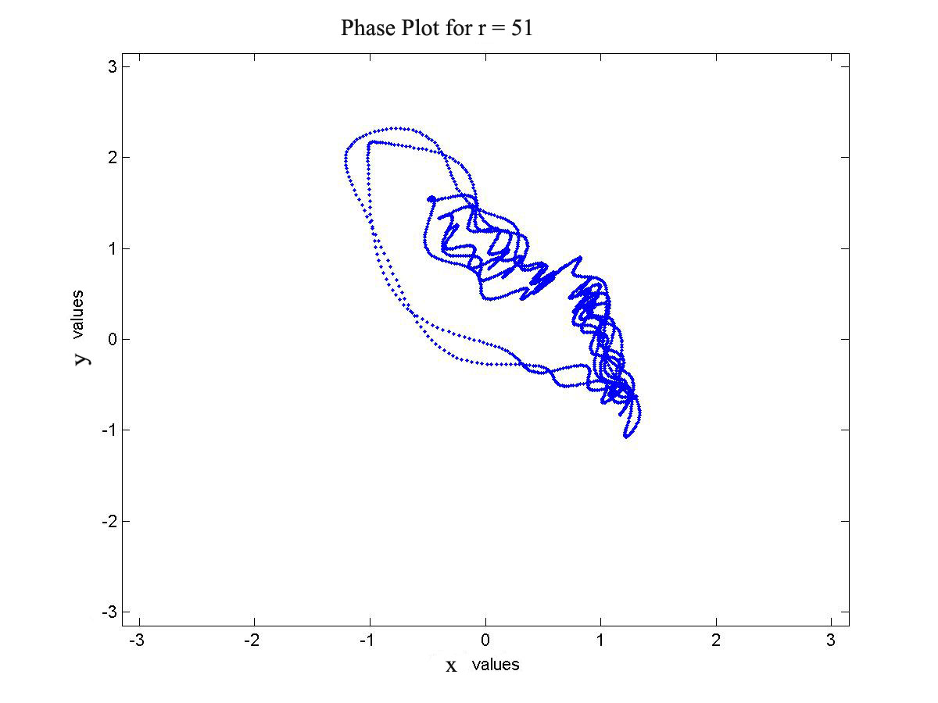

r=100r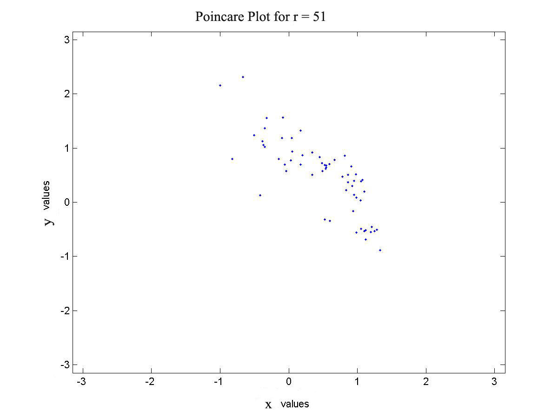
r = 100
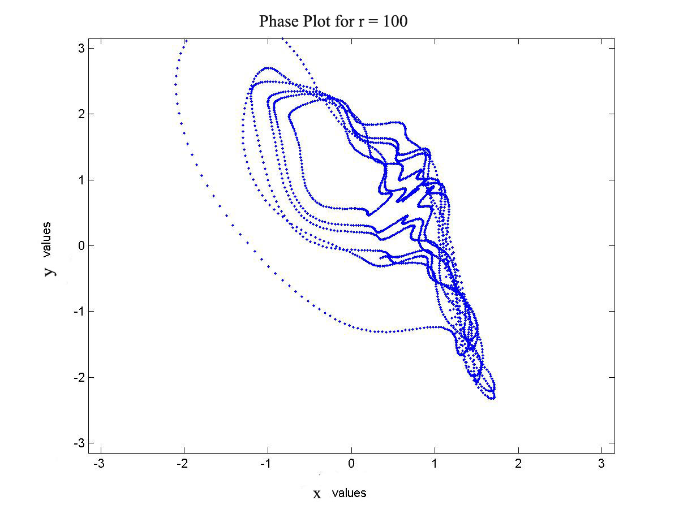
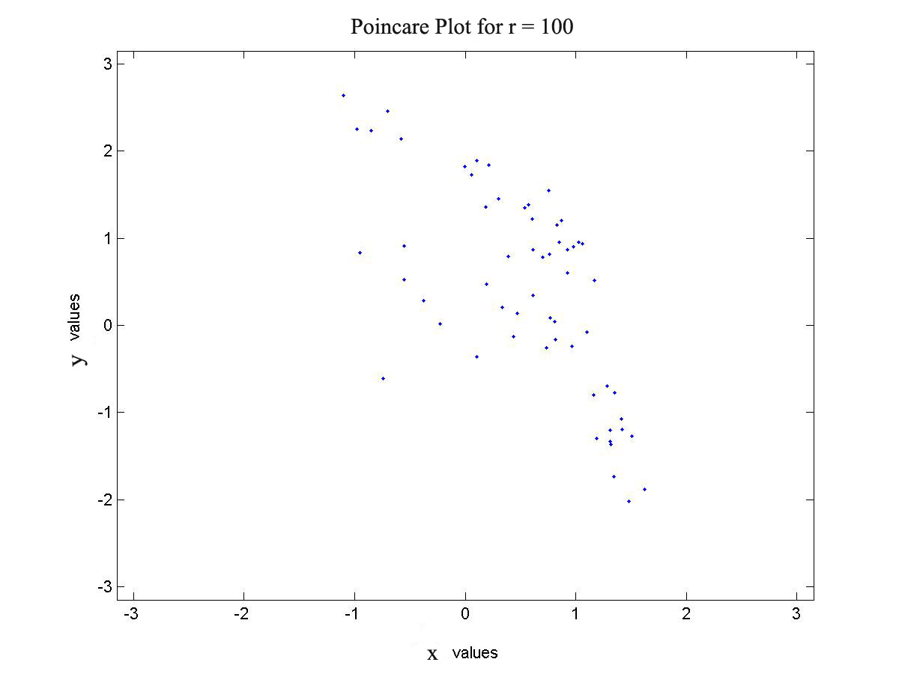

Finally, because we were able to obtain a decent amount of data, we constructed a bifurcation diagram using a Matlab program we wrote (in the appendix):
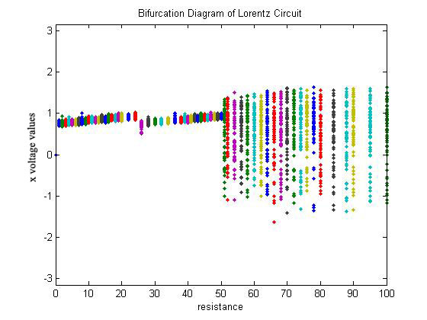
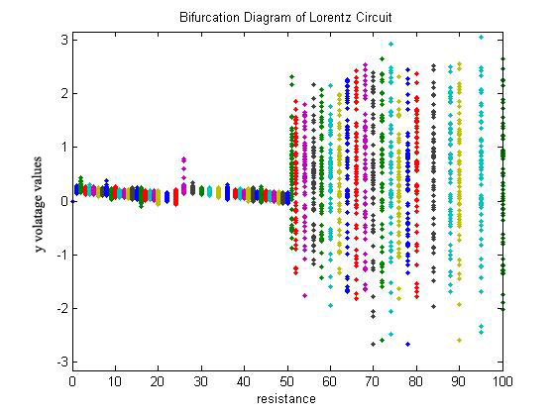
The bifurcation diagrams show us that there was periodicity for the first 50 values of resistance. As can be seen in the Poincare plots, there is slightly more disturbance for the r=50 plot than the r=1. Unlike the pendulum, we see no evidence of period doubling or quadrupling or even a semi-chaotic region before the system enters into chaos; instead a very abrupt transition from periodicity to chaos occurs at r=51. Once in chaos, the system does not return to periodicity.
In conclusion, while chaotic motion is unpredictable, it is also governed by laws of motion. There exist clear boundaries in which a system can remain completely periodic and also in which a system can be chaotic. By consulting bifurcation diagrams and Poincare plots a genuine understanding of the dynamics of the system can be obtained.

Works Cited:
- http://www.phy.davidson.edu/StuHome/chgreene/Chaos/Pendulum/pendulum_content_frame.htm
- Baker G.L, Gollub J.P, Chaotic Dynamics, Cambridge University Press: 1996.

Appendix
Diagram One: the Apparatus
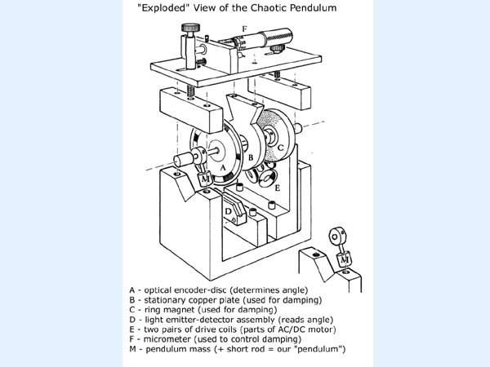
The Code:

Used to create the functions and their Fourier Transforms in the Theory section:
t = 0:0.001:1;

x = sin(2*pi*10*t)+sin(2*pi*20*t)+sin(2*pi*40*t)+sin(2*pi*50*t);
y = x;
plot(y)
title('Periodic Function')
xlabel('time (seconds)')

Y = fft(y);

Pyy = Y.* conj(Y);
plot(Pyy)
title('Frequency content of y')
xlabel('frequency (Hz)')

Used to find the power series of our data

t = 1:2500;

x = r1(:,1);
y = x;
plot(y)
title('Periodic Function')
xlabel('time (seconds)')

Y = fft(y);

Pyy = Y.* conj(Y);
plot(Pyy)
title('Power spectrum of Data')
xlabel('frequency')

% For data r1, this outputs a peak at 61, which means that the
% function goes up and down 61 times during the 2500 points
% so the period is just 2500points/61times = 41 points

Used to printout the phase plots and the poincare plots. Everywhere it says ‘here’ is where we changed the name so that we could analyze a different set of data.

d = 41;
c=1;
px=[];
py=[];
r=r1; %here
n=1; %here

while (d<=2500)
px(c,n)=r(d,1);
py(c,n)=r(d,2);
d=d+41;
c=c+1;
end

plot(r(50:2500,1),r(50:2500,2),'.')
axis([-3.15,3.15,-3.15,3.15])
title(n)
xlabel('theta values')
ylabel('omega values')
print -djpeg rr1 %here

plot(px(:,n),py(:,n),'.')
axis([-3.15,3.15,-3.15,3.15])
title(n)
xlabel('theta values')
ylabel('omega values')
print -djpeg rr1_p %here

Used to create the Bifurcation Diagram.
counter=1;
while (counter<20)
x(1:60,counter)=counter;
counter=counter+1;
end

while (counter<38)
x(1:60,counter)=counter;
counter=counter+2;
end

while (counter<52)
x(1:60,counter)=counter;
counter=counter+1;
end

while (counter<=80)
x(1:60,counter)=counter;
counter=counter+2;
end

x(1:60,84)=84;
x(1:60,88)=88;
x(1:60,90)=90;
x(1:60,95)=95;
x(1:60,100)=100;
%plot(x,px,'.')

Mathematica Code to generate the experimental Poincare plots
