Rapid Prototyping of 3D Cyclic Olefin Copolymer (COC) Microfluidics Chip Using Hot Embossing Method for Facilitating Protein Crystallization and X-Ray Crystallography
by
Min-Sung (Chris) Hong
Bachelor of Science in Biological Physics
Brandeis University, 2015. 5. 11

Submitted to the Department of Physics
in pursuing an honors degree in Biological Physics
at the
Brandeis University
May 11th, 2015
© Brandeis University 2015. All rights reserved.

Rapid Prototyping of 3D Cyclic Olefin Copolymer (COC) Microfluidics Chip Using Hot Embossing Method for Facilitating Protein Crystallization and X-Ray Crystallography
by
Min-Sung (Chris) Hong

Submitted to the Department of Physics
on May 11th, 2015, in fulfilling the requirement
of the Honors degree in
Bachelor of Science in Biological Physics

ABSTRACT
Understanding protein biochemistry and protein structure at the atomic level are key steps for understanding how proteins function, how proteins interact with other proteins and small molecular weight molecules both intracellular and intercellular to the cell, and what kind of conformational changes they undergo. In addition to acquiring basic knowledge about protein function, structural knowledge can be exploited to create new antibiotics and improve current medication by utilizing structural-guided synthesis. Structural analysis of protein is most commonly done by obtaining X-ray diffraction patterns from protein crystals. Therefore crystalizing protein is a critical step in the structure pipeline. Obtaining X-ray diffraction pattern requires protein crystals that are obtained through protein crystallization method, but the generating crystals is the major bottleneck in protein structure determination. Obtaining the atomic-resolution of three-dimensional structures from protein crystals requires following a delicate order of processes, each requiring the successful completion of all prior steps in order to proceed on to the next. Protein crystallization is the major bottleneck in protein structure determination because for every protein the necessary conditions for it to crystalize is highly specific with many different parameters to be considered. In the case that crystallization occurs after screening all possible range of precipitants, crystals are cryo-cooled to minimize radiation damage and mounted in a X-ray beam line. Crystals that are selected need to be large enough to provide diffraction pattern from many different crystal orientations in order to obtain enough information for the full structure. However, this conventional method is highly laborious, time-consuming, and it is challenging when the crystals are small and since the thermal stresses induced during cryo-cooling will damage such small crystals, which in turn degrades the quality of the diffraction data. Conventional crystallization methods, such as hanging drop method, the microbatch method, and microdialysis do not offer enough control over the physical-chemical parameters that influence protein crystallization to reach the optimal condition necessary for protein crystallizing. Fabricating a high-throughput microfluidic device made out of the thermoplastic cyclic-olefin copolymer (COC) that can store 1-2 uL of solution in 380 identical wells that are 400 um wide with ~40um deep, allow growing protein crystals using well-controlled crystallization conditions combined with x-ray diffraction data collected in-situ at room temperature eliminates not only the challenges that are mentioned above, but also removes the need to cryo-protect the crystals. Thereby the osmotic stress and thermal stresses that are induced during cryo-protection is removed. With microfluidics that allows precise and controllable nucleation and growth conditions, one crystal is formed for each one of 380 wells, and each crystal that are formed has the same unit cell, which enables one to merge diffraction sets from different crystals in the chip. Compared to the previous microfluidics device made out of thin PDMS layer lidded with COC sheets, which takes ~10hours to be made, this new technique fabricates the same functioning device in less than 6 minutes, giving 120 times reduction in fabrication time! With COC’s advantages over PDMS this fabrication method can be used to replace other microfluidics devices’ fabrication methods, which are currently made with PDMS. This new fabrication technique holds promising features that will revolutionize the way proteins are crystallized for structural analysis and it has the potential to be commercialized, with production rate of 10 fully functioning devices per hour, which is the only way to make this technology accessible to the broad science community. In this paper the fabrication processes are described and the resultant COC device is characterized.

Thesis supervisor: Seth Fraden
Title: Professor of Physics

Thesis supervisor: Zvonimir Dogic
Title: Professor of Physics

Acknowledgements

All the experiences and skills I gained from pursuing this senior thesis would not have been as fruitful and enjoyable as it have been without Professor Seth Fraden. I am very fortunate to have him as my thesis advisor during this past year at Brandeis University. I would like to express a sincere appreciation to Prof. Fraden for the times he has spent working with me while performing experiments, for his kind and generous teachings and helpful guidance and advices that has helped me start a job as an R&D researcher at Bio-Rads. Through working under Prof. Fraden, I have learned to think differently when approaching a problem in research, and most importantly I have learned to become an independent researcher as well.
I would also like to thank Achini Opathalage, Markus Ludwig, and Gregory Widberg for supporting me as well to get this far in my thesis work.
Finally, I would like to thank my parents, who have always given me never-ending love and support.
The project described in this thesis was supported by Materials Research Science and Engineering Centers (MRSEC).

Contents

1. Introduction
2. Background
2.1 Microfluidics for Serial Crystallography
2.2 High-throughput fabrication
3. Experiment
3.1 Material Selection
3.2 Hot Embossing with Linear Thermal Press
3.3 Profilometry
3.4 Sealing(Lidding)
3.5 Fluid flow

4. Results and Discussions
4.1 Hot Embossing Result
4.2 Sealing(Lidding) Result

5. Conclusions

6. Bibliography

CHAPTER 1
INTRODUCTION
Proteins are arrangements of amino acids that are joined together in polypeptide bonds, with lengths ranging widely from couple tens of amino acids to tens of thousands of amino acids. Proteins are found in many places within living organisms. To list some of the main reasons why scientists want obtain the atomic-level three-dimensional structure of proteins are that one can find out (1) how the functions of proteins and their structures are related, (2) how proteins interact with other proteins or enzymes to carry out certain tasks, (3) how enzymes, nucleic acids and other macromolecules operate alongside with proteins of interest, and etc… Pharmaceutical companies, biotechnical and chemical industries are highly interested in obtaining protein structures for their applications in protein engineering, rational drug design and other applications to biological systems. In human Homo sapiens with the total genome size of about $3.22×{10}^{9}$ base pairs that form into 19042 different protein-coding genes, and according to the Bionumbers database, those genes code for about 28913 number of distinct proteins. And from the Protein Data Bank’s 2014 annual report, it is stated that only 1087 different Homo sapiens proteins have been structuralized. Thus, there is a great need to obtain more structural data of proteins that have not been structuralized. The conventional procedure of obtaining atomic-level resolution structures of non-structuralized proteins is by first crystalizing them into a highly concentrated (300-500mg/ml) crystals, which is essentially the highest purified state of a protein with ordered three-dimensional array of molecules. Then X-ray beam from synchrotron source with wavelength of around 1 Å is shown through the protein crystal to create a unique diffraction pattern for different crystals that gets detected onto a charge-coupled device (CCD), and then through further steps one can obtain a high quality electron density map. Figure 1 below shows the outline of the above-mentioned steps to obtain protein structures. However, the crystallization process itself remains a major bottleneck in protein structure determination.
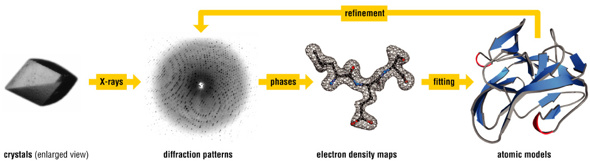

Figure 1. Pictorial outline of steps involved in protein structure determination process: (from left) protein crystallization to obtaining diffraction patterns to generating electron density map, and finally obtaining the atomic model of protein.
TThe concept of vapor diffusion has served as the basis for commonly used conventional crystallization methods, such as sitting drop method, hanging drop method, sandwich drop method and many more. However, these methods do not offer sufficient control over the physical-chemical parameters that influence protein crystallization process, and it sometimes requires as much as milliliters of volume of expensive and rare proteins to crystalize, and proteins will not form a homogeneous three-dimensional array of protein molecules, but in heavy-bulk units, making the structural analysis significantly difficult. Once proteins crystallize, crystals need to be carefully picked out and poured with cryo-coolants for protection against X-ray, and these two processes are both highly laborious and time-consuming. Additionally using the conventional method for obtaining X-ray diffraction pattern reduces the yield of free-electron beams hitting the crystals to 1% chance, making the step of obtaining diffraction patterns of crystals a difficult process.
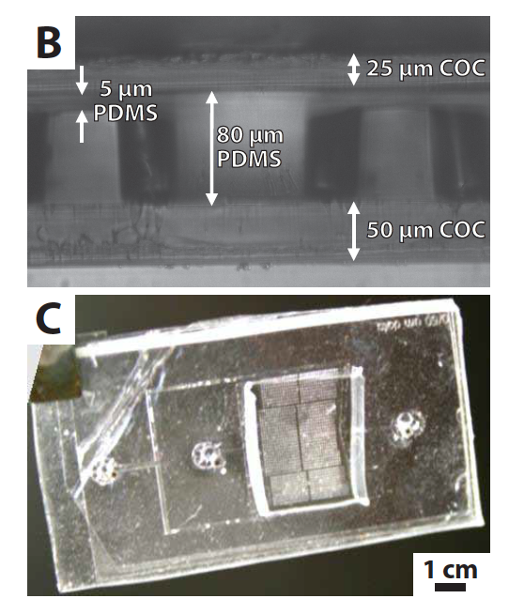
Microfluidics devices have been used in numerous labs as solution to many biological and clinical experiments because microfluidic handling enables accurate, rapid and low cost analysis. Microfluidic systems can also provide wide range of capabilities for experimental parameters control, such as an establishment and control of biochemical and thermal gradients, and in vitro studies for biological experiments. Our previous work done by Heymann et al. on serial crystallography using transparent polydimethylsiloxane (PDMS) microfluidic devices that have the channel features made through photo-lithography technique with top and bottom sealed by Cyclic Olefin Copolymer (COC) or Kapton-foil (as shown in Figure 2), has demonstrated the capabilities of our high-throughput microfluidic serial X-ray crystallographic technique using synchrotron beam source to obtain a full atomic-level 3D structure of glucose isomerase to 2 Å resolution. However, the soft lithography method for fabricating the PDMS microfluidic device takes 10 hours to complete, which puts limitation for high-throughput manufacturing, and thus significantly reduces the capability to commercialize such technique.
Figure2. Picture of the PDMS microfluidics device for serial crystallography
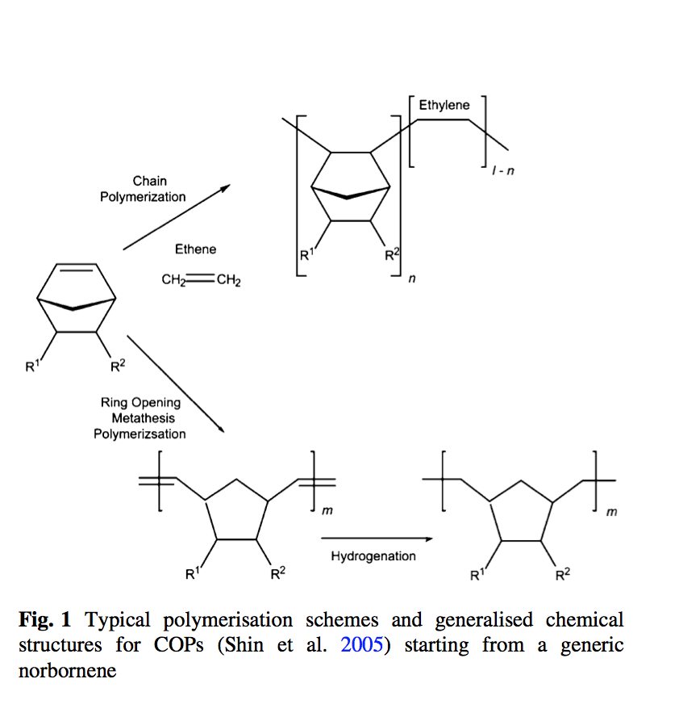
Material selection for fabrication work is crucial for fabricating microfluidics devices, since they largely dictate the performance, applicability and the manufacturability of the device being made. Cyclic Olefin Copolymers (COC), which is a type of thermoplastics, are gaining popularity over PDMS as a substrate material for microfluidics due to their promising advantages, such as high chemical resistance, low water absorption, good optical transparency in the near UV range, and low material cost. Figure 3 shows a chemical structure of COC and the TOPAS product that we have used for our experiments. Polymeric materials have been marked to be a good alternative to conventional materials, like glass and silicon, allowing to mass fabricate microfluidics devices at an inexpensive costs. The high chemical resistance opens door for the first to use polymeric material for microfluidics systems. COCs also present a high biological inertness that makes them a good material for biomedical experiments. The low water absorption of COC ensures that the device channels remain unchanged throughout the experimental time. Additionally, the hydrophobicity nature of COC is another great advantage why it is such a suitable match for microfluidic devices. This eliminates the laborious and time-consuming process to surface-treat the hydrophilic surfaces of conventional PDMS devices with a commercial water repellent agent, Aquapel.
Figure 3. A schematic of chemical synthesis of TOPAS Cyclic Olefin Copolymer product that we used for our experiments.
TOPAS®
ZEONOR®

In this paper, we have described a new method of a rapid fabrication of a fully functioning high-throughput microfluidic serial X-ray crystallographic device made out of COC for facilitating protein crystallization process, which remains a major bottleneck in determining protein structures. We used hot embossing process for creating the channels in a blank COC for our device, and this method enables a high throughput manufacturing of microfluidic devices made out of COC for better optical property and less channel deformation change due to water absorption, which has been an issue for PDMS devices. This technique will reduce down the fabrication time for all different purpose microfluidics device by 120 folds, and manufacturing with inexpensive COC material with a production rate of about 10 devices per hour offers a promising potential, along with partnership with biotech industries, to commercialize this technique to the broad protein crystallography community. We have also investigated issues causing challenges for replication process and the quality of the fabrication outputs from each process. This new fabrication technique can revolutionize the conventional method of microfluidic device manufacturing processes that rely on curing PDMS, which takes about 10 hours to complete. Microfluidics devices fabricated in a high-throughput manner is the only way microfluidics approach to solving issues in protein crystallization difficulties can be commercially available for wide scientific communities.

CHAPTER 2
Background
2.1 Microfluidics for Serial Crystallography
Serial crystallography works in a way that is completely different compared to how conventional protein X-ray crystallography has been done. Wherein X-ray crystallography solves a protein structure obtained from a complete diffraction data obtained from a single fairly large protein crystal that has been effectively cryocooled, Serial Crystallography uses many number of small, single, unoriented crystals that are not cryocooled and (Guha et al., 2012; Chapman et al., 2011; Boutet et al., 2012), then obtaining numerous diffraction patterns by transmitting X-ray beams to many but small, and essentially identical crystals, and then merging all the diffraction patterns together to get a complete diffraction pattern. According to Heymann et al., this serial crystallography work with non-cryocooled crystals has been found to have several technical advantages over conventional method, such as avoiding the roughly ten fold increase in crystal mosaicity that arises during cryoprotection, and eliminating the need to perform cryoprotection procedure. This different approach in serial crystallography using microfluidics requires some understanding of how the microfluidics system works in this device. One should refer to figure 5, 6 and 7 to understand the fluidics work involved in this microfluidics device that makes this serial crystallography work. When nanoliter sized protein solutions are stored in each well, and stabilized by surfactant, nucleation occurs in each drop of small volume, and in each well initiation of a negative feedback mechanism lowers the supersaturation in the surrounding protein solution as the crystal grows, which Heymann et al. has exploited to produce one crystal per drop. As the nucleation rate is low enough, growing crystal will consume enough of the protein in solution to decrease the supersaturation rate so that further nucleation event will be improbable. When all the drops have nucleated crystals, the device is immersed into an oil to slow down the evaporation rate. With an optimized crystal growth condition, crystals are grown in this serial diffraction chip, X-ray diffraction data are acquired, and the structures are found.
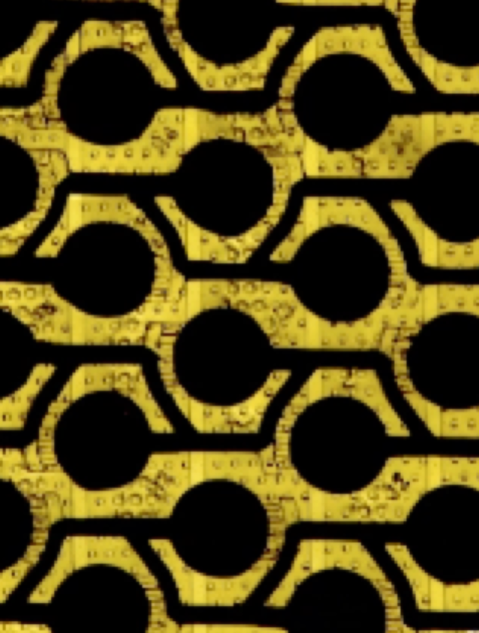
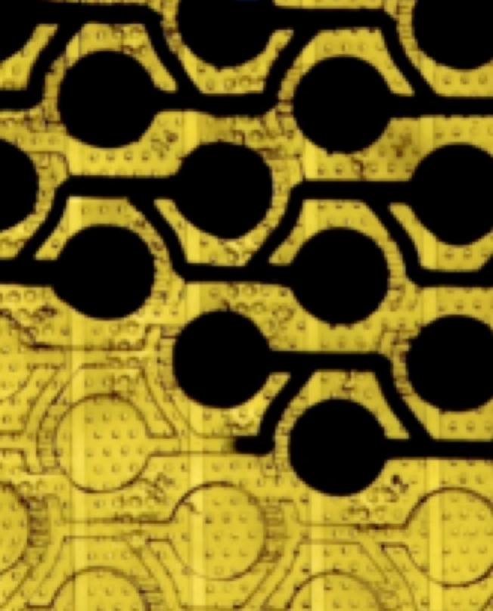
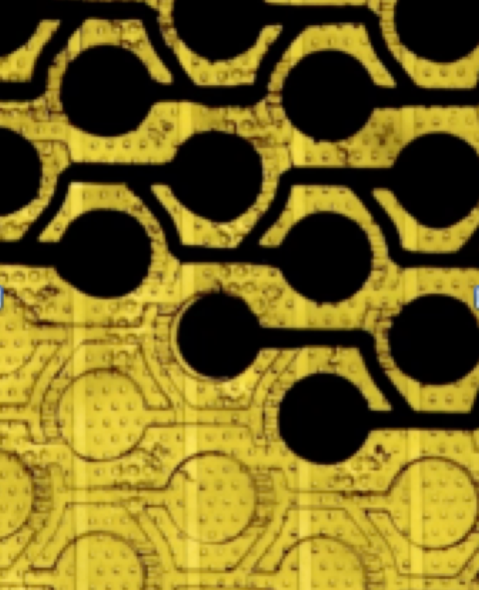
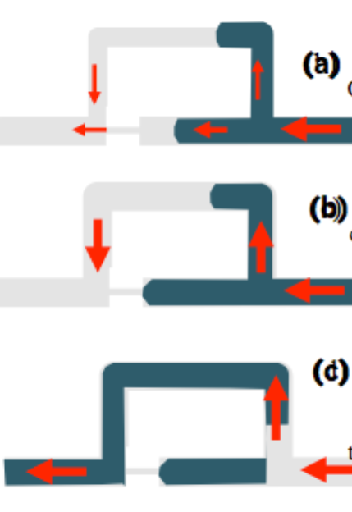
Figure 6. Step-by-step explanation from (a) to (d) how protein solution is stored and confined in each well. (a) device channels are first filled with protein solution or other aqueous phase, then (b) the narrow capillary valve acts as a plug to ensure 100% of flow to go through the by-pass. (c) oil(viscous phase) is injected in to generate stored drops.
Figure5. Schematic of channel pathway of our protein crystallography microfluidics device. There are 380 wells per device that are placed in such a manner.

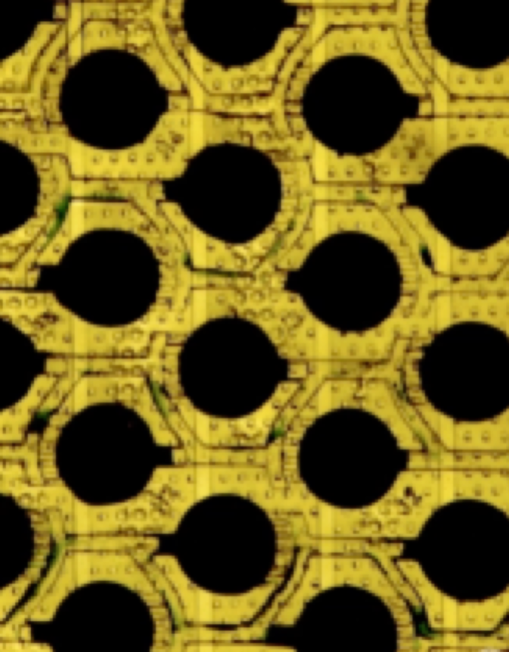
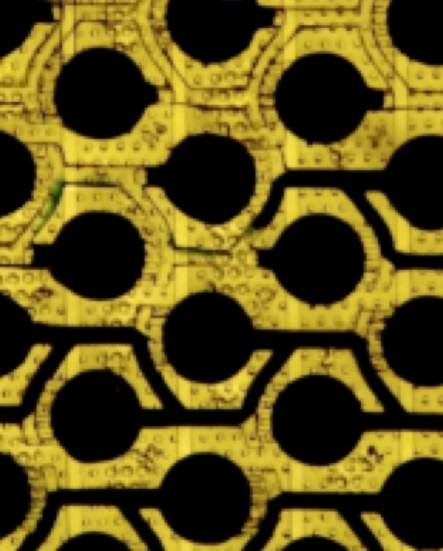
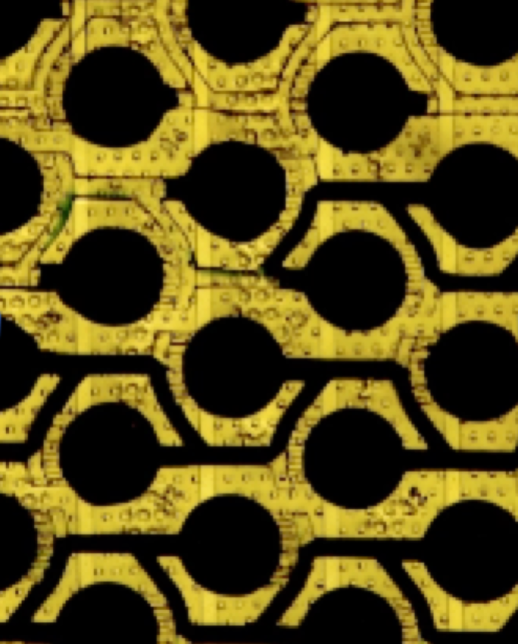
Figure 7 c) All the wells in the device filled up with protein soln.
Figure 7 b) solution going through by-pass
Figure 7 a) Protein solution filling up a well.
Figure 7 d) Oil phase being introduced. It is right before the oil will flow through the by-pass, generating a stored drop in a well. This occurs because capillary valve acts as a plug that forces oil to travel through by-pass
Figure 7 e) 100% of oil phase traveling through the by-pass.
Figure 7 f) Drops are stored in every well in the device.

2.2 High-throughput fabrication

Fabricating microfluidics devices by hot embossing method and using inexpensive thermoplastic COC as a base material for our device and other microfluidics devices for different purposes give two big advantages. First, hot embossing is a high-throughput and easily controllable technique that can lead to faster and cheaper way of production, which can also be improved by selecting the right material one chooses to emboss. The second big advantage comes from using thermoplastic COC instead of PDMS because the nature of COC is hydrophobic and not porous. Using COC as our device material will reduce significantly the undesirable absorption of hydrophobic proteins, which frequently occurs in PDMS devices leading to change in device channels. Also low glass transition temperature of COC allows quicker and accurate production rate for hot embossing, which is a key parameter to be chosen for high-throughput fabrication method.

CHAPTER 3
MATERIALS and METHODS
3.1 Material Selection
The main material for fabricating our microfluidic X-ray chip is cyclic olefin copolymer (COC). There are many different manufacturers, such as TOPAS, Zeonor, PSC, Akshar Plastic Inc, and etc… that offer different types of COC with different glass transition temperatures and thicknesses. The COC material used in this study was 101.6um thick TOPAS 5013 (Tg 130 °C) from TOPAS company for both as base plate and laminating thin film layer. COC have excellent properties that are listed in the below:

Table1. Advantageous properties of Cyclic Olefin Copolymer for optical devices
High transparency: | High light transmission of 91%
Excellent optical properties: | Low birefringence, high abbe’s number
Low specific gravity: | Specific gravity of 1.02 or less
High heat resistance: | Tg of up to 178° C
Low water absorption: | Dimensional stability and stable optical characteristics
Excellent water vapor barrier properties: | Able to preserve sensitive products
Low dielectric constant, low dielectric loss: | Low loss properties for high frequency signals
FDA-approved: | Compatible with pharmaceutical and food applications
Applicable for various sterilization methods: | Autoclavable, γ rays, EOG

COCs are polymers of cyclic monomers such as 8,9,10-trinorborn-2-ene (norbornene) or tetracyclododecene with ethane, and norbornene undergoing chain polymerization with ethylene or an anionic vinyl polymerization:
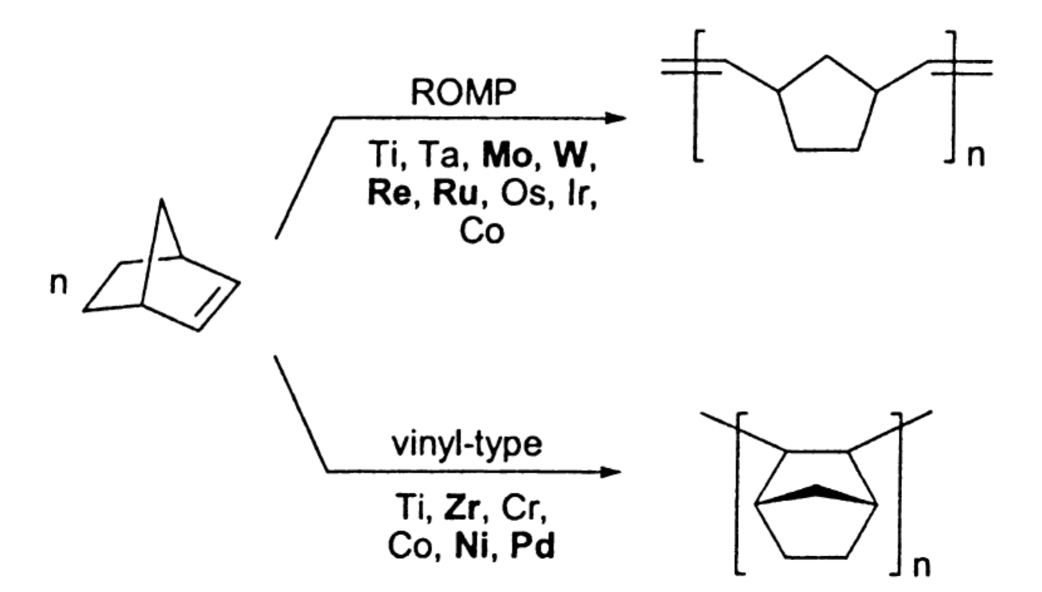

Fig1. C. Janiak, P.G. Lassahn / Journal of Molecular Catalysis A: Chemical 2981 (2000) 1–17, Schematics of two types of polymerization for norbornene with metals used as catalyst for making COP(top) COC(bottom).

The fabrication method of our device is largely divided into three parts: hot embossing, sealing—or also known as lidding, and fluid flow.

3.2 Hot Embossing with Linear Thermal Press Machine
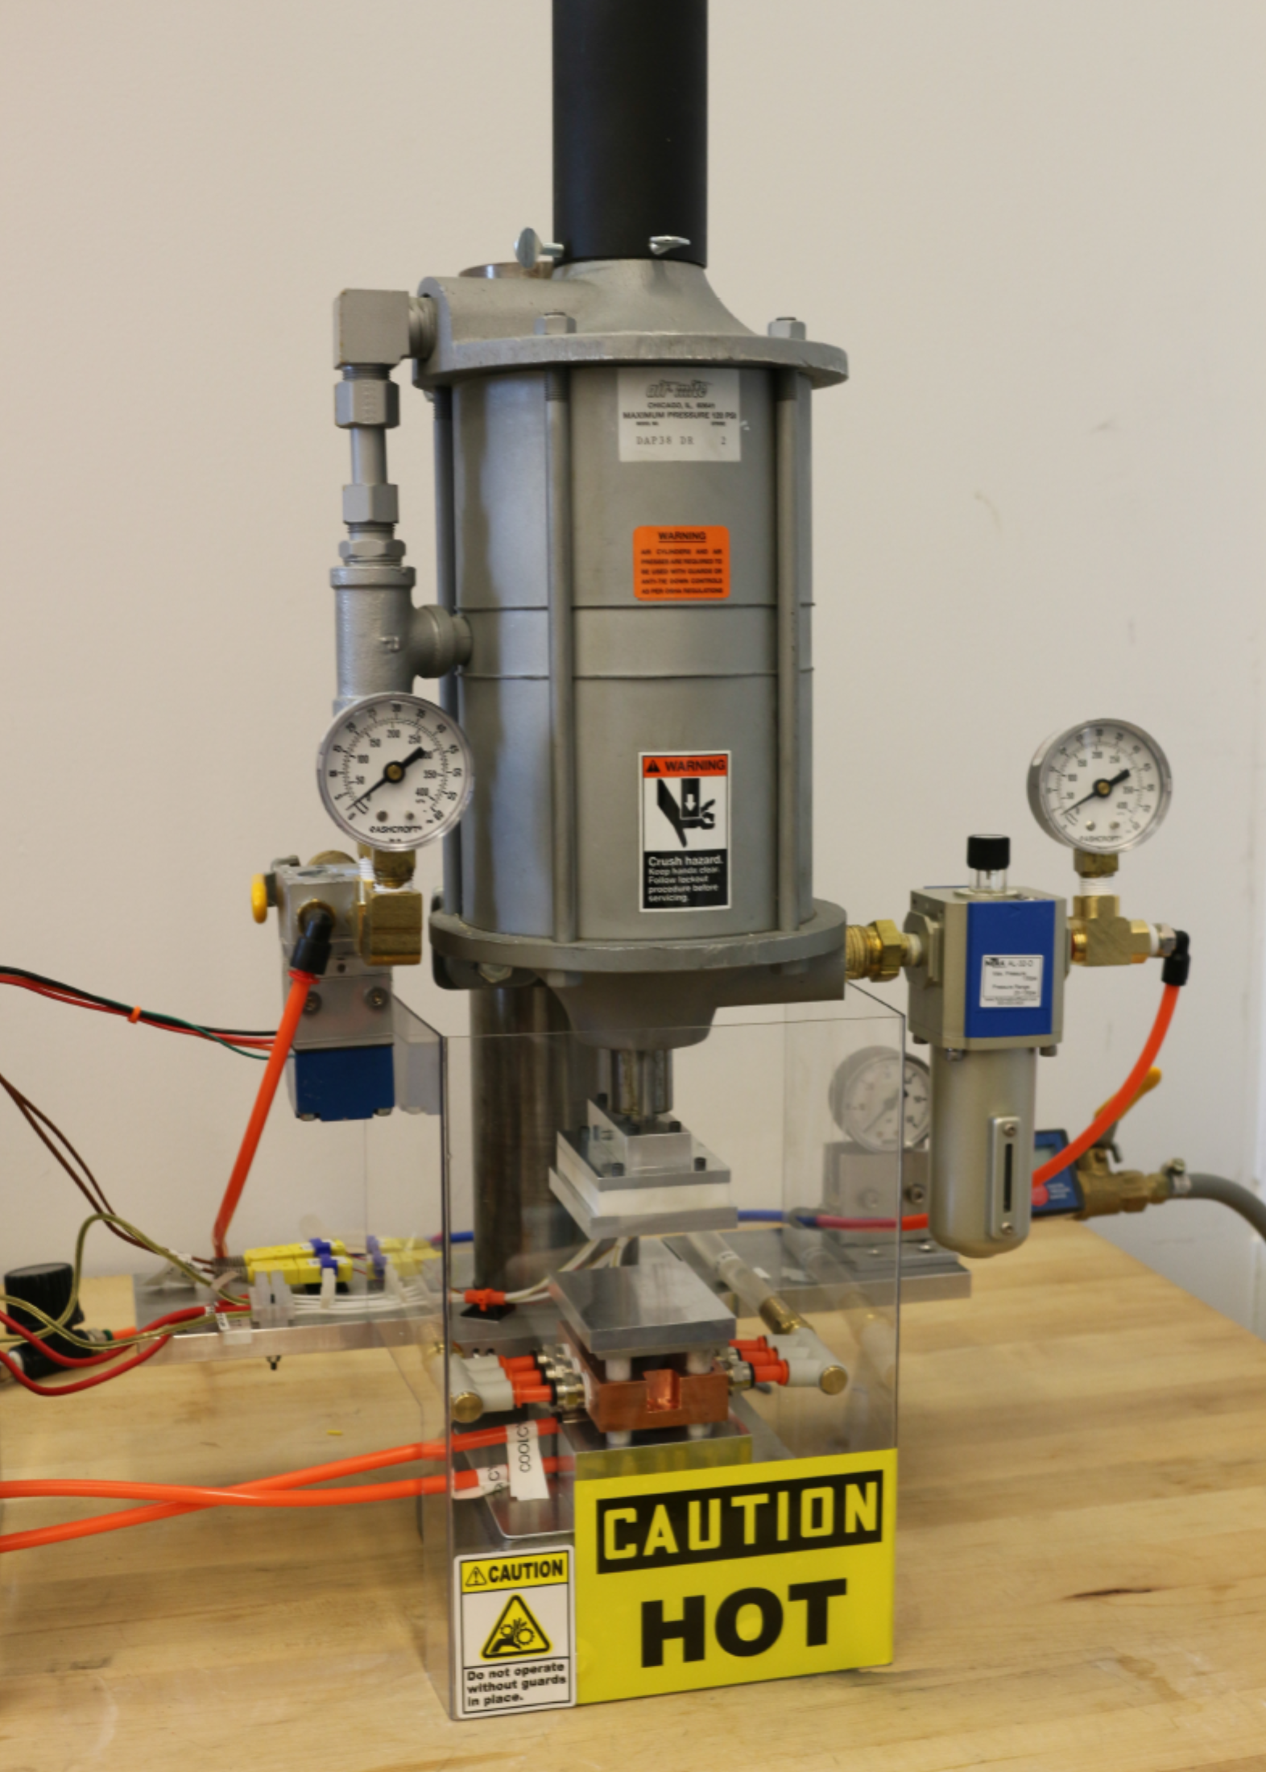
Hot embossing is done with a thermal linear press machine shown in Figure 1, which has a controllable temperature plates and controllable linear pressure to be applied vertically downward. Bidirectional pressure system is used for the pressure controller of our embossing machine. Figure 5 shows a sketch of how this bidirectional pressure system works. This linear press converts voltage output from the computer into controlling the amount of opening of the pressure gauge in the cylinder and uses it as an adjustable pressure controller for embossing. Figure 2 shows a clear schematic and pictures demonstrating the embossing procedure of this thermal linear press machine. Fabrication of PDMS master is done first prior to any kind of embossing of COC, and it is done through photolithography method, as shown in figure 3, to create a silicon master with three layer heights of SU8 photoresist features patterned at a negative extrusion. This patterned SU8 photoresist silicon master is then served as a mold where PDMS is poured on top with a curing agent mixed in a 10:1 ratio by mass, placed under house vacuum for ~1 hr, and then cured in an oven at 80° C for more than 2 hours. It was later found that during application of pressure of hot embossing our PDMS master, when not confined by a frame that holds it in place, goes through pressure-driven expansion, changing the diameter and inlet and outlet distances of the entire device. In order to prevent this issue, we have created a method to generate a PDMS master that will have a target height, length and width that will fit right into an aluminum frame. The methodology of previously mentioned procedure is explained in Figure 6. Then the cured PDMS master is carefully taken off from the silicon master to be placed inside an aluminum manifold for hot embossing. This process of confining PDMS for hot embossing is shown in figure 4 with a three-dimensional explanation of the process.
Figure 1. Thermal Linear Press Machine manufactured from the SCOPE Brandeis MRSEC project.

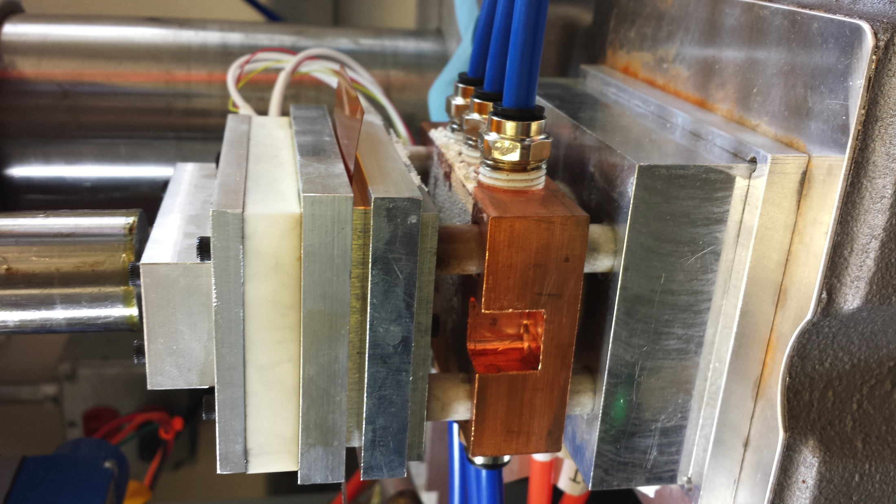
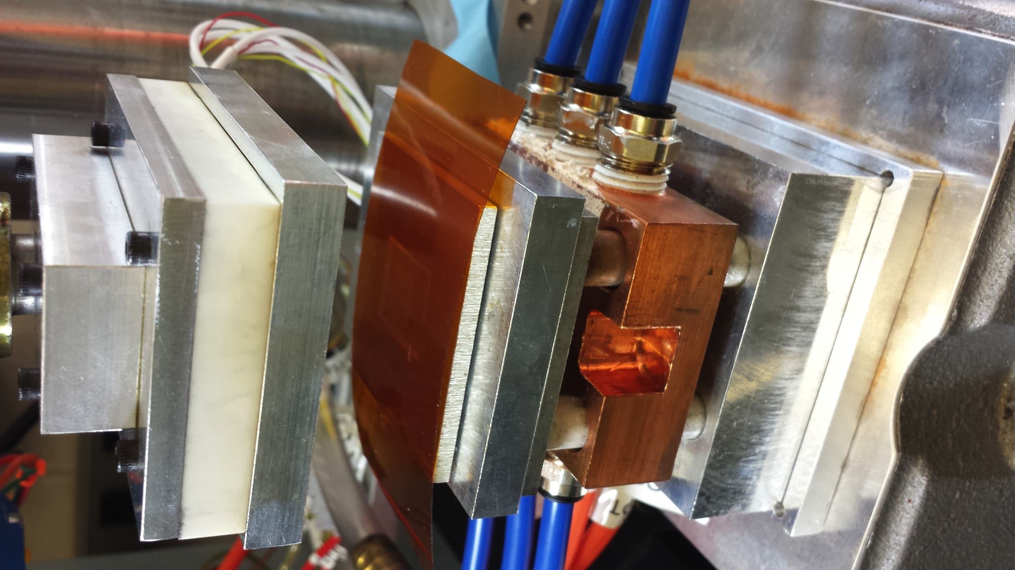
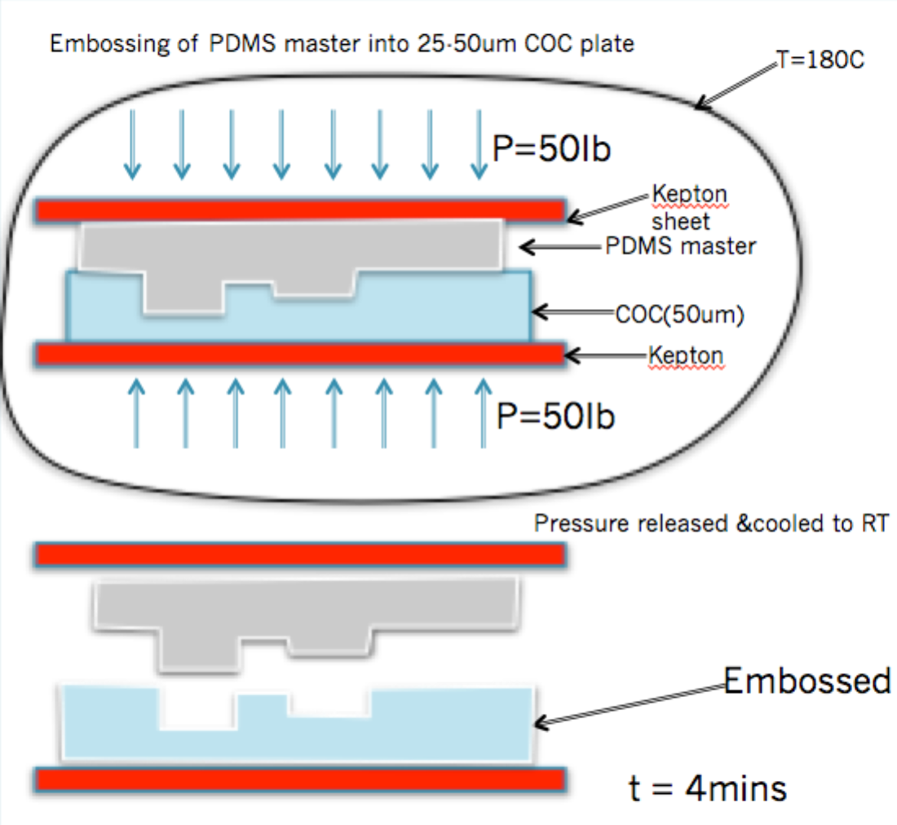
Figure 2. Schematic (right) and picture(left) of thermal linear press that has been in use for hot embossing method. Platens’ temperature and pressure applied to the system can be controlled separately through our lab view code.
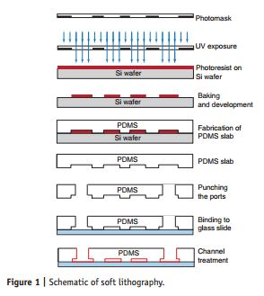
Figure 3. Schematic of photolithography technique for fabricating PDMS devices.

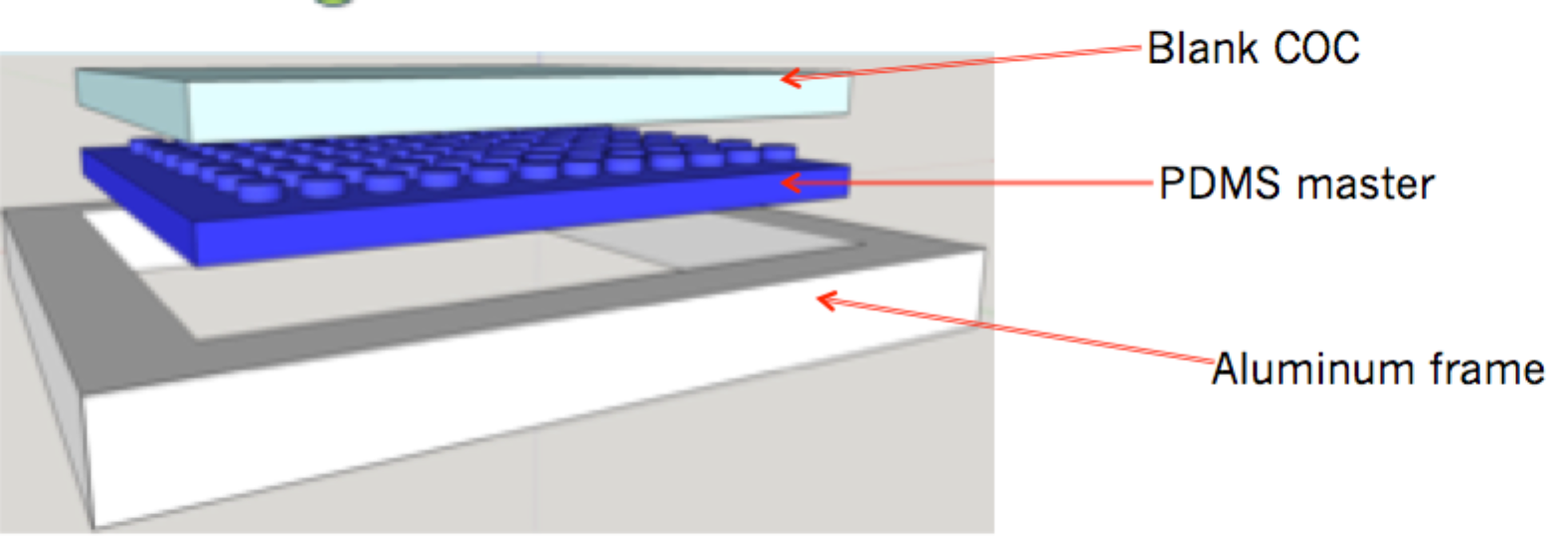
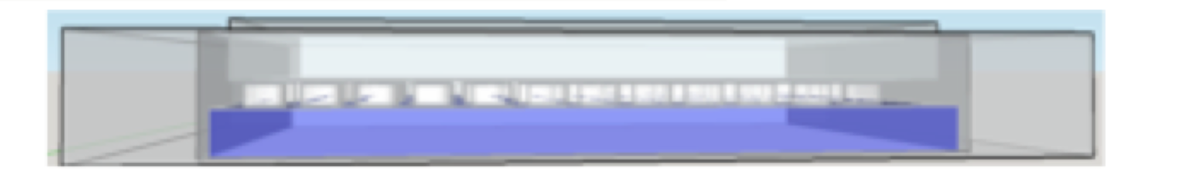
Figure 4. 3D-illustration of confining PDMS master inside an aluminum frame during hot embossing to prevent from pressure-driven expansion of unconfined PDMS master. On the left is shown the three pieces that are required for thermal embossing to work—the aluminum frame, PDMS master that fits right in to the frame, and a blank COC that sits on top of the PDMS master. On the right shows a side see-through view of all three pieces coming together just before hot embossing. About 10-15um of COC sticks out of the aluminum frame so that pressure can be applied downward to the blank COC.

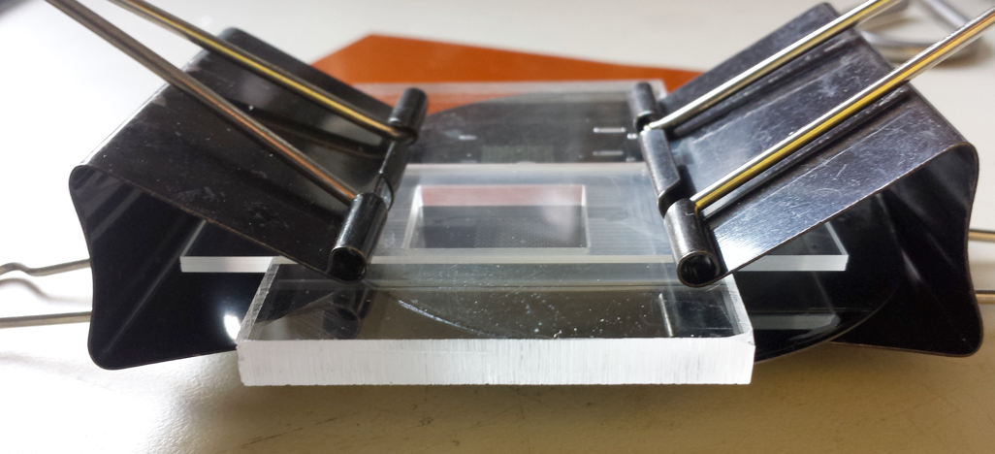
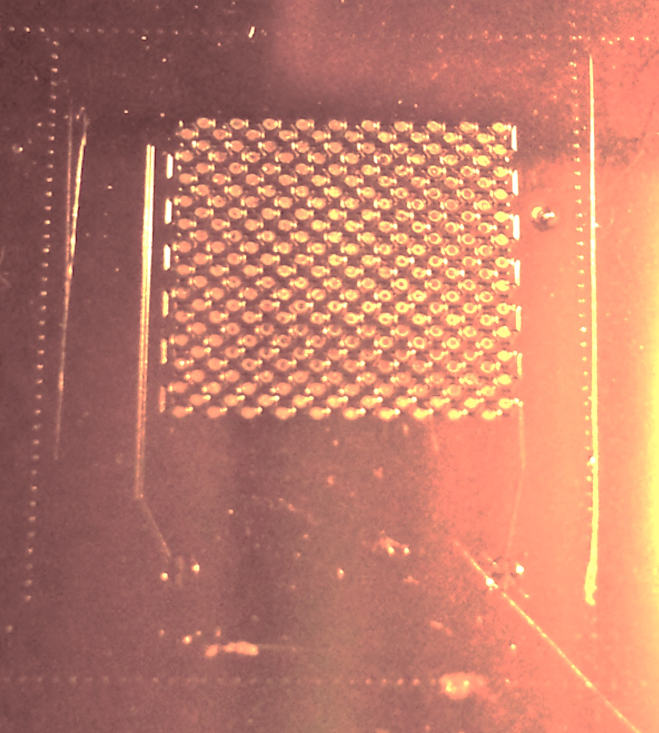
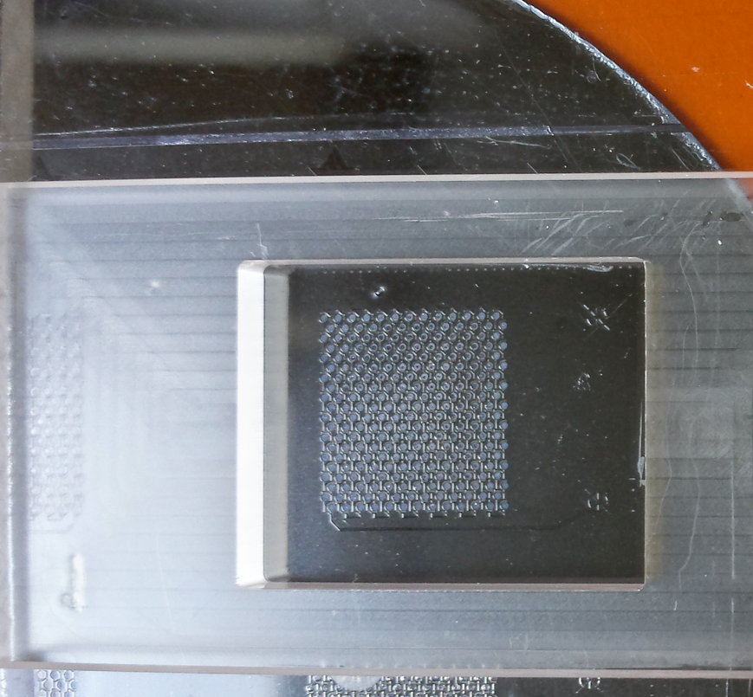
5c) PDMS filled into the empty chamber, then microscope slide is inserted on top to ensure a flat top surface, and then clamped on both sides for oven baking.
5b) Plastic frame sitting on top of Silicon master lined up at the rectangular marker for making PDMS master
5a) Silicon master with rectangular marker

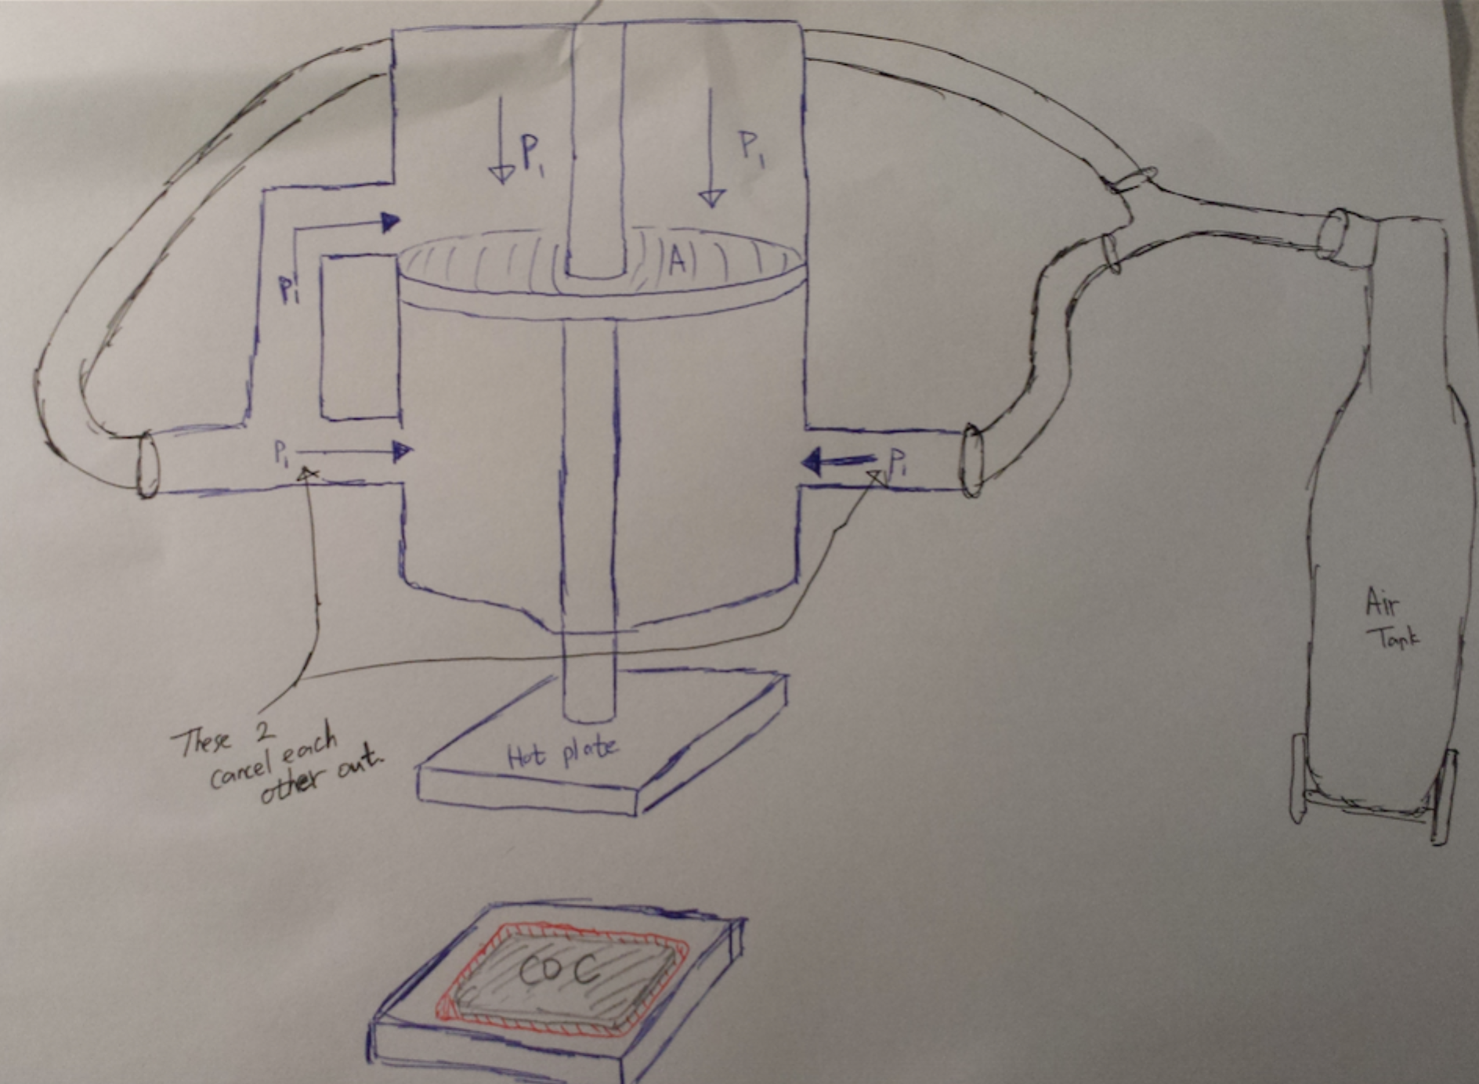
Figure 6. Sketch of bidirectional air pressure flow inside the thermal linear press. As shown in the sketch, two pressures on the lower chamber cancels each other out, and the resulting pressure towards to upper chamber is the resultant linear pressure applied for hot embossing.

Several other components are also involved in this thermal linear press to facilitate the X-ray chip manufacturing process. First, there is an actuated heat sink, which acts as a cooling system and is placed on the bottom of the lower platen. It is a copper heat sink that gets attached once activated, and it will be placed surface-to-surface with the lower platen once activated from the control panel. Copper heat sunk sucks out heat by thermal conduction as a continuous cool water flows through the copper and leaves by taking heat away from the heated copper block. A picture of this copper heat sunk is shown on figure 7 below.
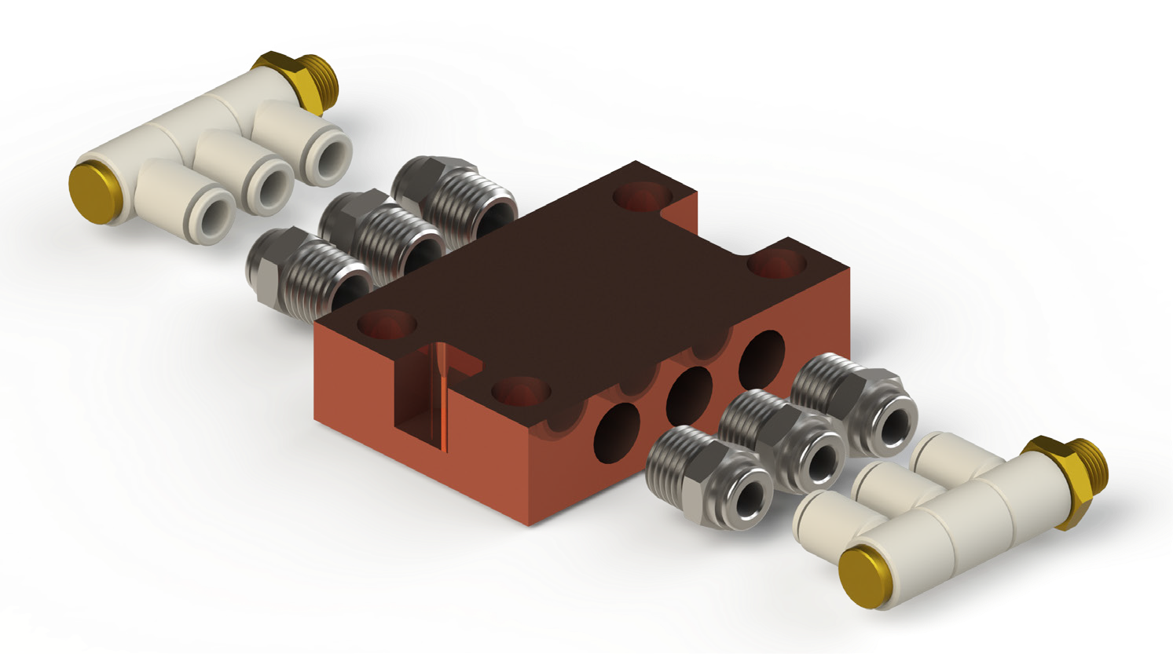
Figure 7. Picture of an actuated heat sink with inlet and outlet holes for water tubing attachment.
Another part of the press is an oil sprayer that ejects small quantities of oil onto the platen metal rod. This is to ensure a smooth lowering of the upper platen during activation of the press.
The entire embossing procedure takes at maximum 5 minutes.
The ideal embossing condition for 50μm, 75um, 100um, and up to 250um of COC with a glass transition temperature ($T_{g}$) of 130 °C is as follows:

Platens Temperature | 180 °C
Pressure Applied | 55 lbs
Time of emboss | 60s
Time of cooling | 180s

Table 2. Ideal conditions for hot embossing microfluidics patterns onto blank COC sheets.

Hot-Embossed chips can do everything that PDMS chips can do and even more.
Faster processing time for this kind of devices will be the key for commercializing this technique. Compared to PDMS method made in the clean room, which requires at least 10 hours to fabricate, manufacturing time for COC devices for the same functions is approximately 100 times faster, and COC chips are better than PDMS in many ways.

3.3 Profilometry
The surface profiles of silicon master and embossed COC device were obtained by using a profilometer (Zeta-20, Zeta, San Jose, CA, USA). The samples were cleaned with isopropanol prior to scan. Figure 1 shows a picture of our lab’s profilometer. It scans with a resolution limit of about 0.75um.

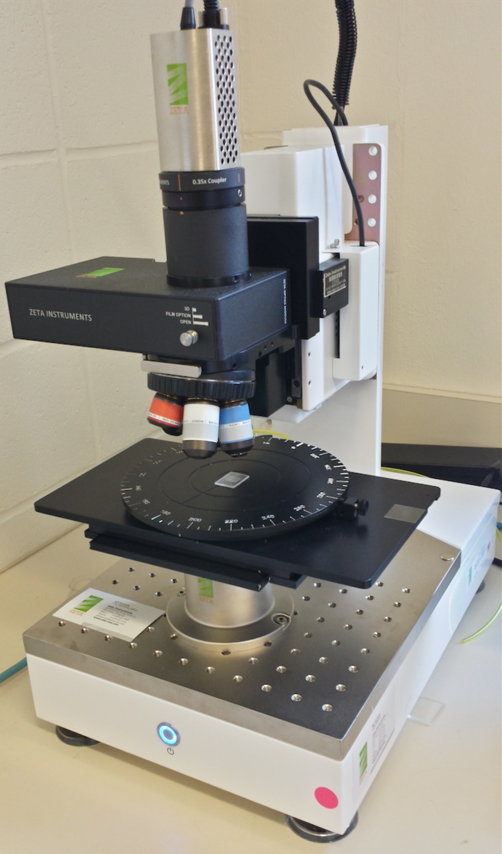
Figure 1. Picture of our lab’s profilometer with PDMS master underneath the objective to be scanned.

3.4 Sealing(Lidding)
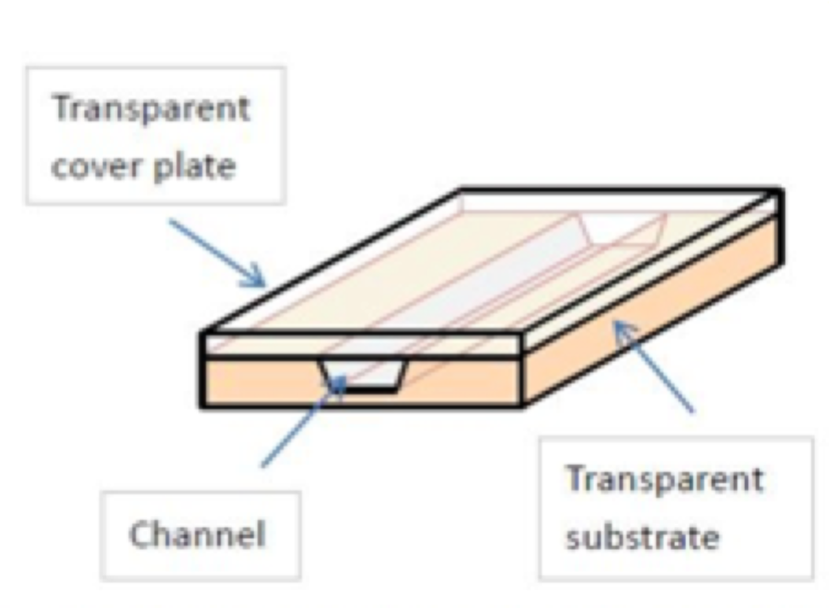
For the microfluidics device to be functional, the embossed channels on the COC plate have to be laminated with a thin film so that the channels will be roofed in order to make experimenting with chemical solutions inside the device possible. Thus, bonding is a critical step in thermoplastic fabrication process, as well as for PDMS devices. However, it is also the most difficult process as well. There are several ways to lid the microfluidics device, such as thermal fusion bonding, adhesive bonding, solvent bonding, welding, and surface treatment and modification, but these methods take quite long to be performed. So in order to shorten the fabrication time for this COC crystallography microfluidics device we have decided to use chemical vapor sealing method, which is using the vapor from cyclohexane solution heated at 36 °C to melt a certain thickness of a blank COC sheet, and then applying that layer on top of the embossed piece. Upon contact with another piece of COC piece, the melted layer of COC sheet will form polymerize with the adjoining polymers of the embossed piece, resulting in an extremely strong bonds. Figure 3-1 represents a simple schematic of sealing a microfluidics device for a better understanding for the readers. Cyclohexane was used as our chemical solvent, because it is known to be reactive with COC. Materials used during this process are temperature-controllable electronic hot plate, a 5ml glass syringe, cyclohexane solution, and a two-level chamber lidding device, which I have personally designed and manufactured. A schematic diagram of our lidding plate is shown below:
Figure 3-1. A simple schematic of sealing of microfluidics device to create open channel microfluidics system.
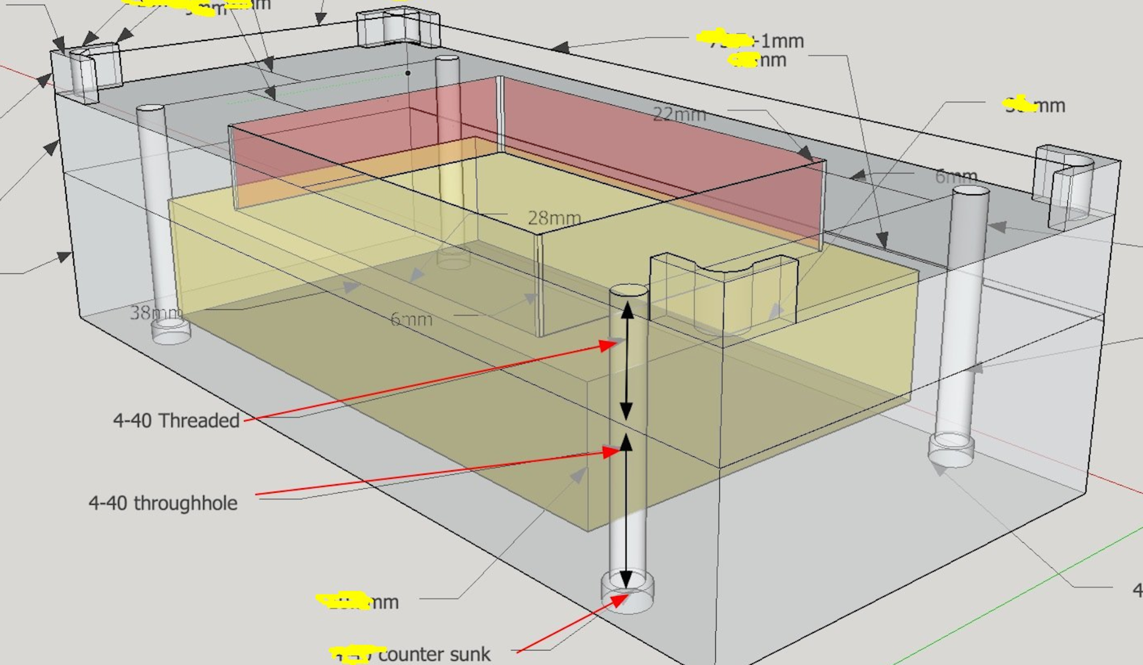
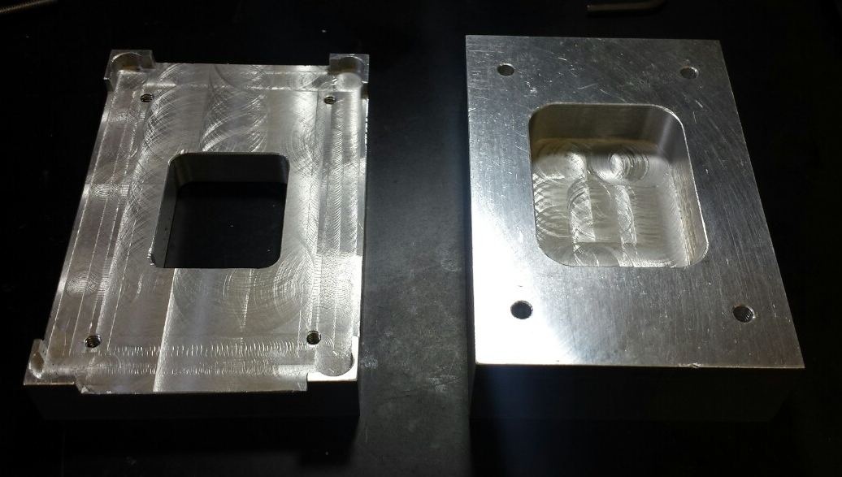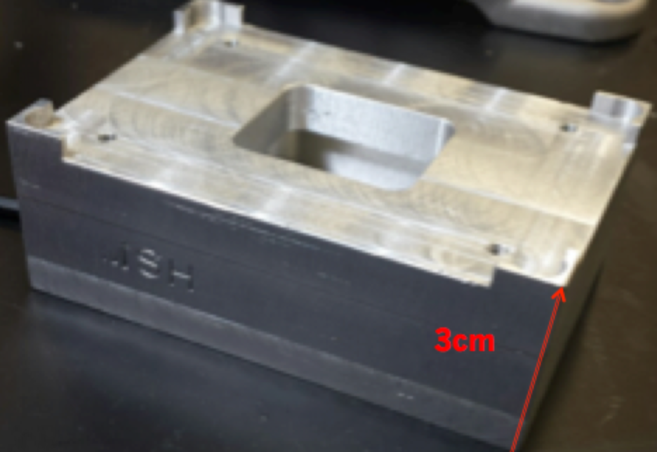
Figure 2. Three-dimensional design of the two-layer chambered lidding plate. It has two layers on top of each other: the yellow bottom layer is for storing cyclohexane, and the layer above is the pathway for vapor to climb up and react with the polymers on the surface of blank COCs. The top frames are for placing a microscope slide with an empty COC sheet taped on at the middle of the glass slide, and then that COC sheet acts as a cap for the top chamber opening in order to maintain a steady and continuous exposure to cyclohexane vapor.

Ideal condition for chemical vapor bonding process:
For using any thickness TOPAS 5013 COC sheets from 2 mils to 10 mils, the ideal lidding conditions was found to be heating the entire metal plate with cyclohexane stored to $T_{lidding}=36°C$ and then exposing blank COC sheet for 90 seconds with 1.5kg of weight placed on top of the microscope slide to prevent any gas from escaping, and then placing the exposed COC sheet on top of the embossed piece with a flat vertical weight of 1.5 Kg applied. A short film of this entire lidding process can be found under the link below. The entire process of sealing takes less than 2 minutes to complete.

3.5 Fluid Flow
In order to confirm a successful sealing of our microfluidics device, one needs to test flowing fluids or air into the device to see if there are any leakages or blockages occurring inside the device. For this process, I have incorporated 3-D printing technology to print out a custom designed manifold that looks like this figure 3.5-1, where the inlet and outlet holes of the COC device (light blue) is matched to the block of PDMS (blue) that is used as a holder for COC devices, as a way to apply equal parallel pressure to all surface area of the device, and as a mean of inserting plastic tubing to the inlet and outlet holes of the device, and the two opening holes on the top piece of the manifold matching the holes for the inlet and outlet of the device, which is to insert tubing easily into the block of PDMS underneath it.
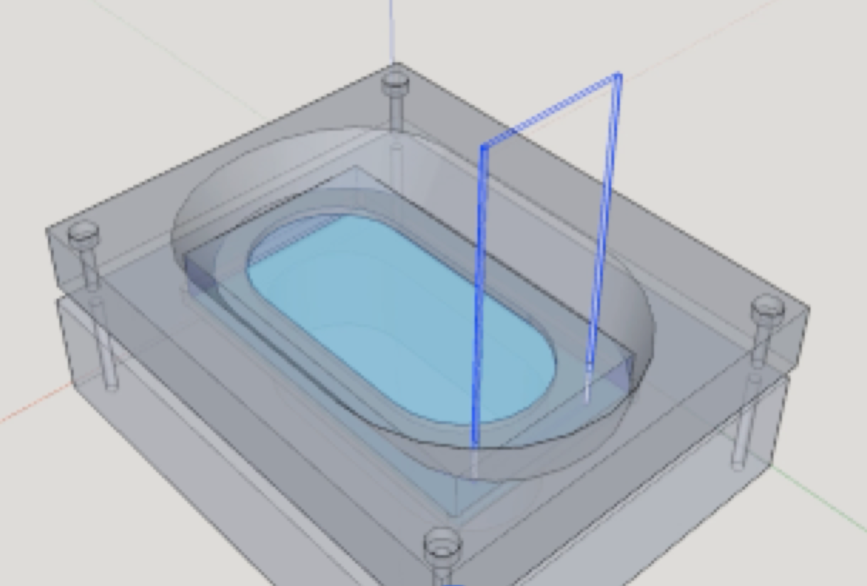
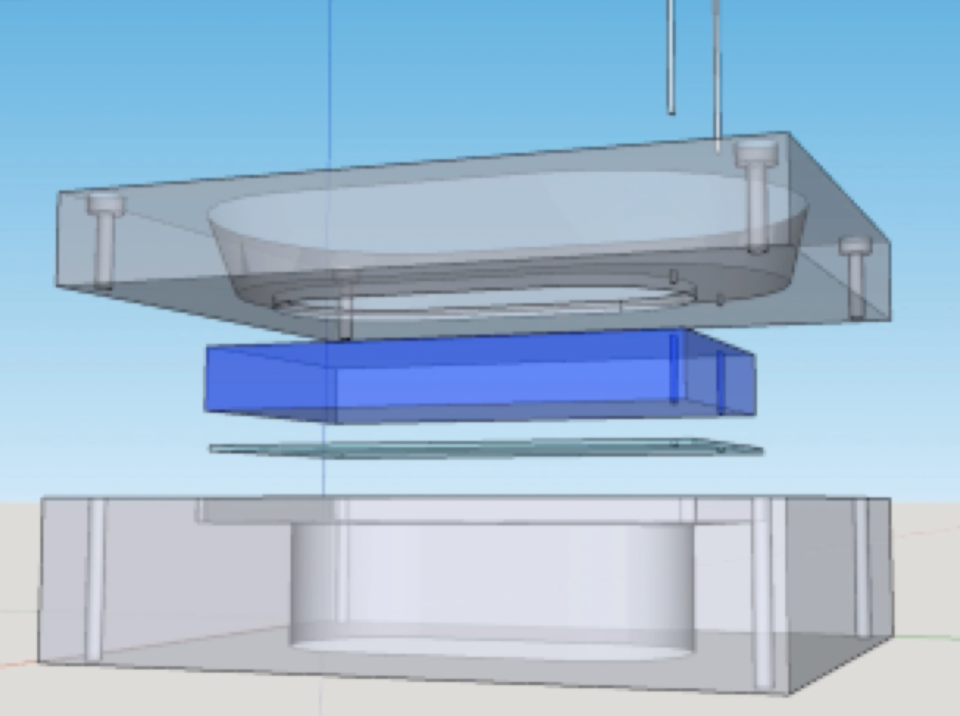

Figure 3.5-1. Sketch-up design image of the manifold for fluid testing. The light blue in the middle is our COC device that gets placed on the bottom of the manifold, and blue PDMS block is placed on top of the device to hold it in place, and then the manifold is screwed tight to ensure successful clamp to prevent any leakage of fluid.
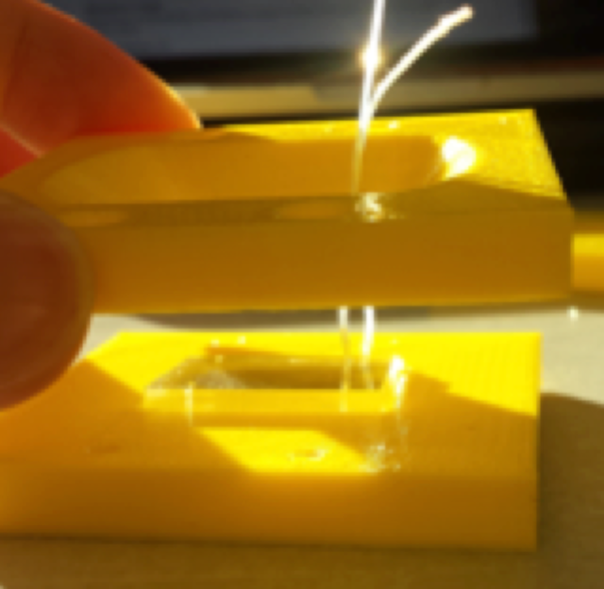
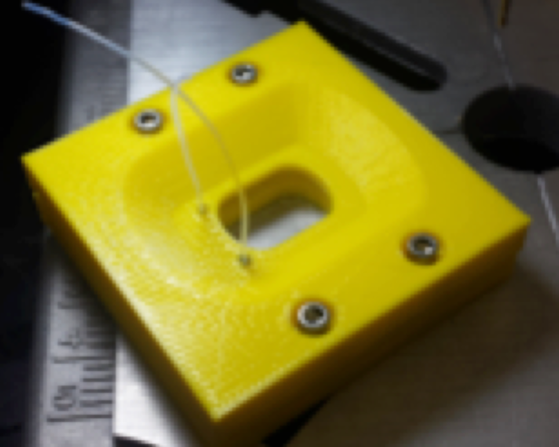

Figure 3.5-2. Picture of the actual 3D-printed manifold. At the top left is shown COC device placed underneath the bottom piece of the manifold with transparent PDMS block placed top of the COC device, and with tubing inserted from the top piece of the manifold. At the top right is shown a screwed manifold that is clamped tightly and ready for fluid injection. The bottom figure is picture of three pieces of 3D print needed to make this work. Left piece is how PDMS block for this manifold gets made. The rectangular size chamber matches that of the bottom piece of the manifold.

CHAPTER 4
RESULTS and DISCUSSION
4.1 HOT EMBOSSING RESULT
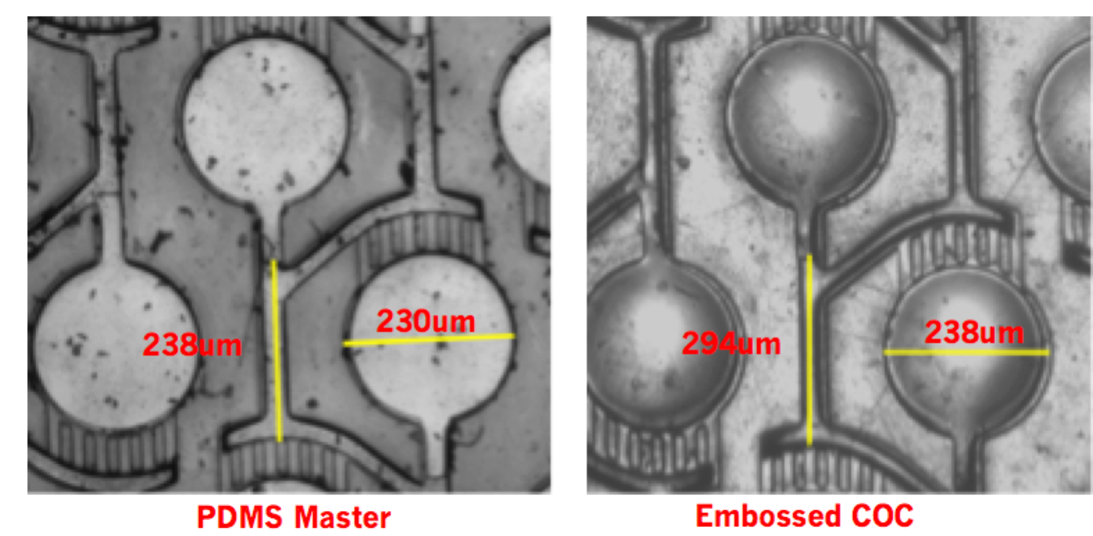
The durability of PDMS master at low working hot embossing temperature at 180 °C allowed a repetitive usage of the same PDMS master mold without a noticeable deformation of the channel features of the PDMS master. However, quantitative analysis of change in the PDMS features has not been made yet. The entire hot embossing process for fabricating COC platform highly is suitable for producing fine quality embossed pieces from the original silicon master. Compared to the embossing with an unconfined PDMS master, which results in significant changes in the embossed feature patterns, such as widening of the wells and lengthening of the by-pass channels, and most importantly widening of the inlet and outlet distance that is crucial when it comes to loading protein solution into our devices, by confining our PDMS master inside an aluminum frame particularly machined for this purpose, we were able to emboss our PDMS master features with no changes on the embossed pieces. Figure 4-1 is a hot embossing result from an unconfined PDMS master. As shown there is a significant changes to the dimensions of the embossed COC pieces.
Figure 4-1. Microscope images of PDMS master and the hot embossed COC during our initial unconfined PDMS master during embossing. There is a significant changes in the dimension of the embossed COC compared to the PDMS master.

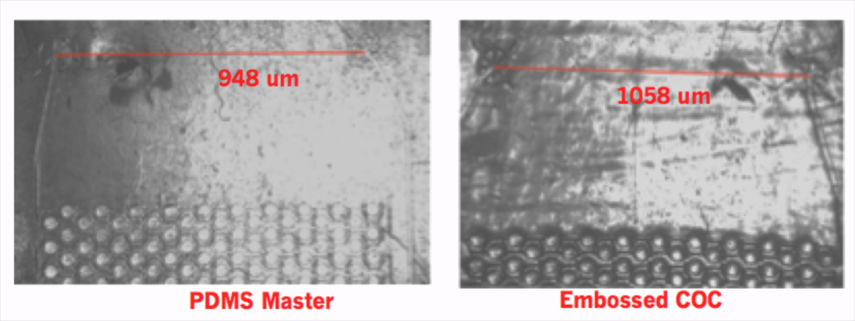

Figure 4-2 (a) to (c) shows the profilometer results from hot embossing starting with silicon master to creating PDMS master, then from PDMS master to creating the embossed COC by confining the PDMS master inside an aluminum manifold, with quantitative analysis of the device features to confirm an accurate hot embossed replication of microfluidic structures in embossed COC platform. From this profilometer scan result analysis, it was confirmed that all the surfaces of the masters, all the dimensions of the channel have been reserved throughout the entire hot embossing process. Even the smallest 20 μm wide capillary valve patterns have been successfully embossed into COC sheets.
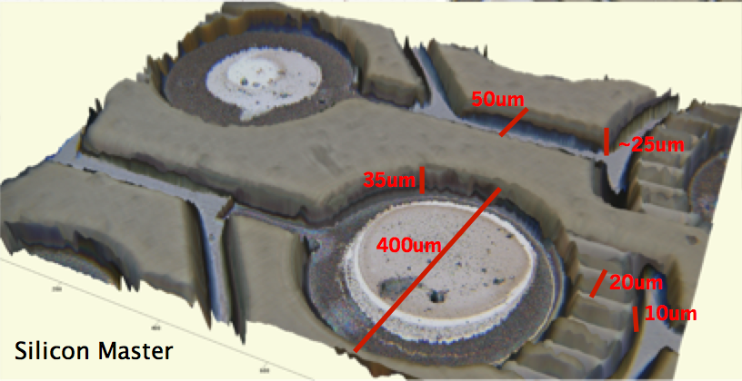

Figure 4-2a) A profile of the silicon master
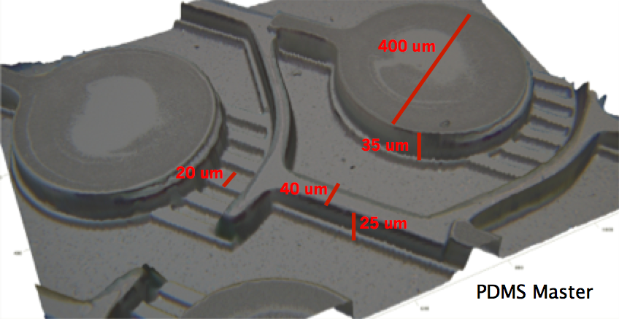

Figure 4-2b) A profile of the PDMS master
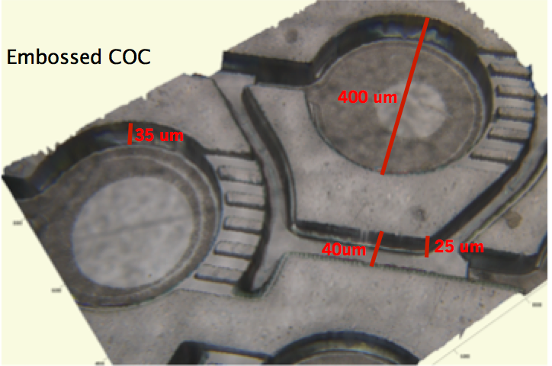

Figure 4-2c) A profile of the embossed COC sheet

This hot embossing process has been giving out repetitive successful embossing results with minimal surface defects that take only about less than 5 minutes to complete, where as creating a PDMS features takes about 10 hours to complete. The next thing that needs to be done is to re-fabricate our silicon master with the rectangular markers, where we place our PDMS curing plastic platform, to have couple hundreds of μm height and the outer regions from that rectangular marker to be at the uniform height so that our PDMS curing plastic platform will lie perfectly flat with no air gaps on the bottom. This will facilitate the fabrication process of PDMS master and as well as preparation of the correct sizes of blank COC sheets to be placed on top of the PDMS master for embossing.

4.2 SEALING (LIDDING) RESULT
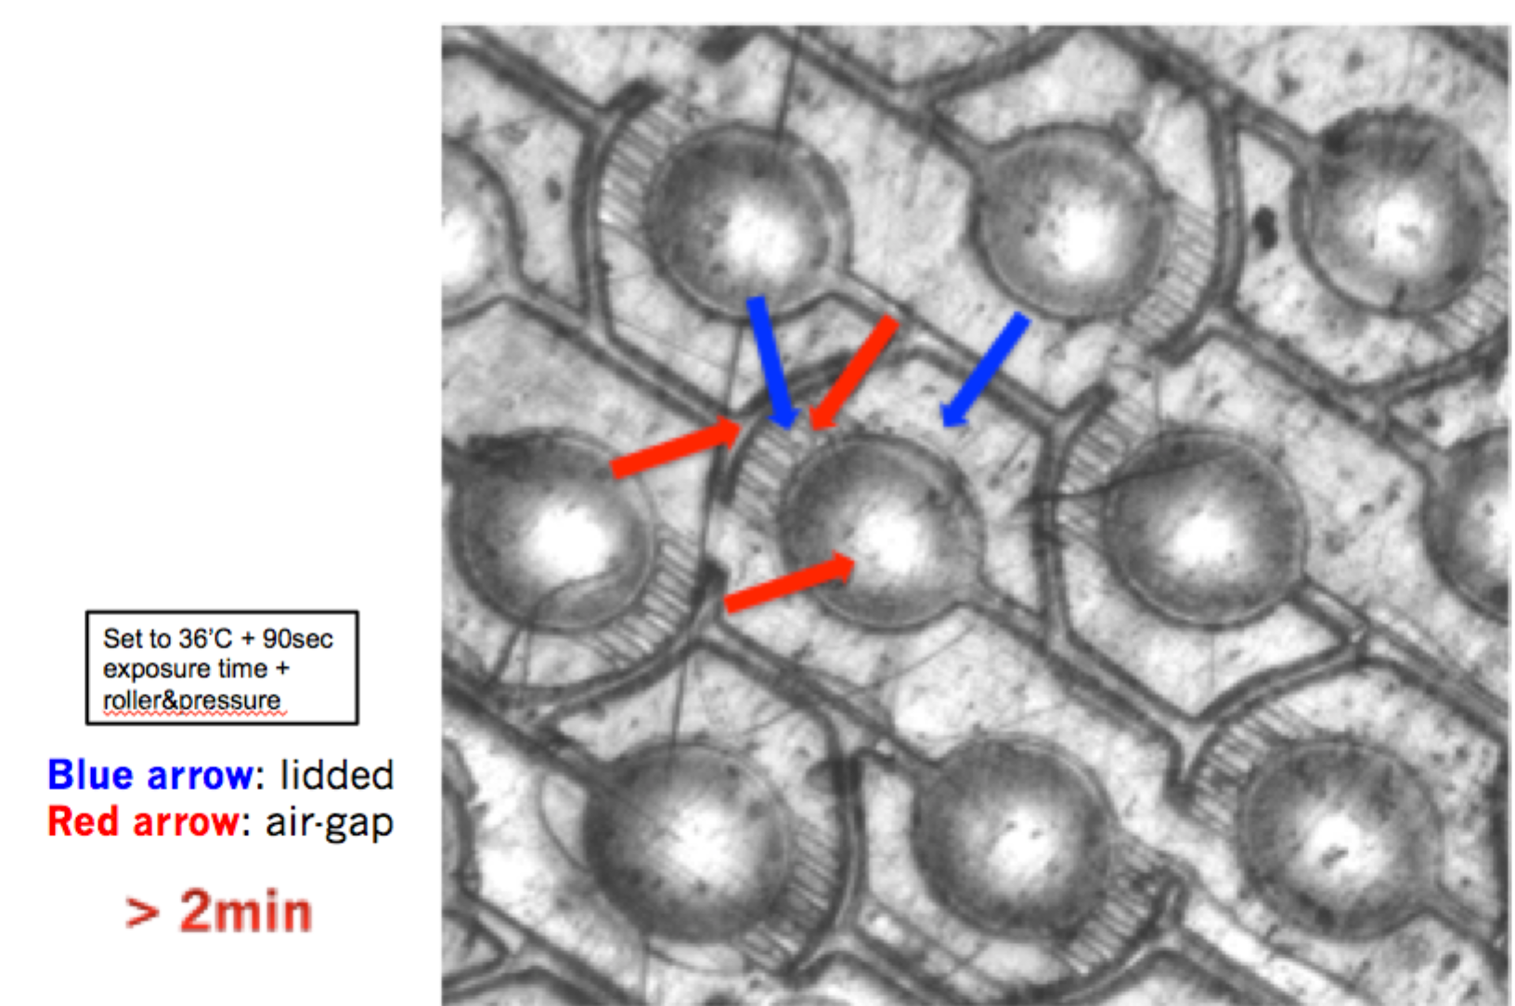
Improving our sealing process with chemical vapor bonding method took the longest time to achieve. However, the result of current-state vapor bonding method is sufficiently successful. As shown in Figure 4.2-1, the optical contrast between the lidded areas (lighter colored) and the air gaps within channels (darker colored) shows a successful lidding, even at the capillary valve regions. This condition that gives out this successful lidding result has been found after testing many different temperatures with different exposure times, and this has been found to give the most stable and repetitive lidding result. The big challenge for lidding has been on the imperfect sealing on the capillary valve regions, where one ore two capillary valves become filled with cyclohexane as shown on the figure 4.2-2 below, where usually one capillary valves lying at the outer-most section of the capillary valves become filled up by the melted COC lid. This is the difficult part of chemical vapor exposure method for sealing. It is difficult to control how much thickness of COC one wants to melt during vapor exposure, and there are many parameters that affect the outcome of lidding as well, such as the uncontrolled air flow inside the fume hood, where cyclohexane vapor exposure of blank COC sheet occur, whether or not the cyclohexane vapor pressure remains constant throughout the entire 90 seconds of exposure time for every trial of lidding, and etc…
Figure 4.2-1. Microscope image of lidded COC device showing an optical contrast between the lidded parts and the air gaps representing the open channels inside the device. The small capillary valves remain open and not filled up by this chemical vapor method of sealing.
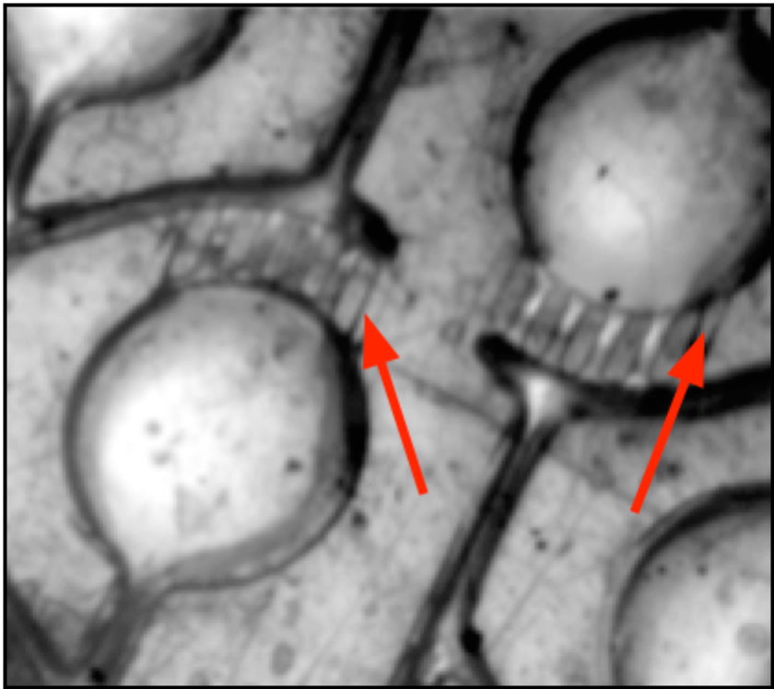

Figure 4.2-2. Microscope image showing imperfect lidding that occurs, leaving usually one capillary valve filled up by the lidded part of the COC.

The next step in sealing process is to reconfigure our capillary valve channel shape by making it bigger in order to ensure that the gaps in the valve will not fill up entirely by the melted COC lid from cyclohexane vapor exposure, with consideration of the Poiseuille’s law of pressure jump across the interface where there is change in the radius.

CHAPTER 5
CONCLUSION

We have presented the rapid prototyping fabrication method microlfluidics device for a serial crystallography using a thermoplastic COC. A hot embossing process with PDMS master that is confined within an aluminum frame in order to prevent pressure-driven expansion of PDMS master when pressure is applied gave an accurate emboss of unchanged microfluidics channel dimensions in the embossed COC platform, even the smallest 20 um length capillary valves. And the entire process takes less than 5 minutes. The cyclohexane vapor sealing method to lid thin COC film to the embossed COC plate gave a successful sealing result, with most of the capillary valves remaining opened and unblocked most of the time of lidding using chemical vapor sealing method, which takes less than 2 minutes to complete. All this process combined takes less than 6 minutes to complete, which is about 120 folds reduction in fabrication time compared to fabricating PDMS devices used for the same purpose. As fabrication method of this COC microfluidics serial crystallography device is near completion and having made sure that both oil and aqueous phase solution do flow into the fabricated devices, the future work will be to use lysozyme or glucose isomerase protein solution to test the crystallization of one crystal per well, make a simpler design for the device to improve the loading efficiency, and then to use the synchrotron beam source to obtain a complete diffraction dataset to test the functionality of this device. As using thermoplastic COC for microfluidics system presents several key advantages over conventionally used PDMS-based devices, such as high chemical resistance, low water absorption, good optical transparency in the near UV range, low material cost, and hydrophobic-nature of substance, using COC as key fabrication material for microfluidics system will completely revolutionize the way microfluidics system for many different studies, like protein crystallography, cell culture platform, in-vitro studies, and other biomedical experiments, with a potential to be commercialized to broad scientific community at a cheap price.

Bibliography
- Overview of Post-Translational Modification (no date) Available at: https://www.lifetechnologies.com/us/en/home/life-science/protein-biology/protein-biology-learning-center/protein-biology-resource-library/pierce-protein-methods/overview-post-translational-modification.html (Accessed: 1 May 2015)
- Stevens, R. C. (2000) ‘High-throughput protein crystallization’, Science Direct, 10
- Sicard, D., Chevolot, Y., Souteyrand, E., Imberty, A., Vidal, S. and Phaner-Goutorbe, M. (2013) ‘Molecular arrangement between multivalent glycocluster and Pseudomonas aeruginosa LecA (PA-IL) by atomic force microscopy: influence of the glycocluster concentration.’, Journal of molecular recognition : JMR., 26(12), pp. 694–9. doi: 10.1002/jmr.2333
- Heymann, M., Opthalage, A., Wierman, J. L., Akella, S., Szebenyi, D. M. E., Gruner, S. M. and Fraden, S. (2014) ‘Room-temperature serial crystallography using a kinetically optimized microfluidic device for protein crystallization and on-chip X-ray diffraction’, IUCrJ, 1(5), pp. 349–360. doi: 10.1107/s2052252514016960
- Nunes, P. S., Ohlsson, P. D., Ordeig, O. and Kutter, J. P. (2010) ‘Cyclic olefin polymers: emerging materials for lab-on-a-chip applications’, Microfluidics and Nanofluidics, 9(2-3), pp. 145–161. doi: 10.1007/s10404-010-0605-4
- Tsao, C.-W. and DeVoe, D. L. (2009) ‘Bonding of thermoplastic polymer microfluidics’, Microfluidics and Nanofluidics, 6(1), pp. 1–16. doi: 10.1007/s10404-008-0361-x

It is a process of evaporating out water from a drop of diluted protein solution and inorganic salts to bring the drop of protein solution into a chemical equilibrium with a pool of precipitant reservoir that lies underneath it
What I mean by the reduction of yield for the free-electron beams of hitting the crystals down to 1% is that during free electron density mapping process many numerous crystals are passed through…
(Heymann, 2014)
(Heymann 2014)
The Poiseuille’s Law states that the pressure difference in order to make a fluid flow through a small diameter goes by $P_{diff}≈1/{{radius}^{4}}$.
(Stevens, 2000)
(Overview of Post-Translational Modification, no date)
Heymann. Michael., Opthalage. Achini., Wierman. J.,
(Sicard et al., 2013, pp. 694–9)
(Same)

